DEPARTMENT OF COMPUTER APPLICATION

TKM COLLEGE OF ENGINEERING

KOLLAM-691005



23MCAP206-Advanced Database Management Systems

PRACTICAL RECORD BOOK

Second Semester MCA

2024-2025

Submitted by

NAME: BHAVYA ULLAS

REG NO: TKM24MCA-2025

DEPARTMENT OF COMPUTER APPLICATION

TKM COLLEGE OF ENGINEERING

KOLLAM-691005



Certificate

This is a Bonafide record of the work done by BHAVYA ULLAS(TKM24MCA2025) in the Second Semester for the lab course Advanced Database Management System 23MCAP206) towards the partial fulfillment of the degree of Master of Computer Applications during the academic year 2024-2025

Staff Member in-charge Examiner

…..………………………….. ……………………………

|  |  |  |
| --- | --- | --- |
| **S.No** | TITLE | PAGE.NO |
| **1.** | Experiment 1 | 1 |
| **2.** | Experiment 2 | 10 |
| **3.** | Experiment 3 | 24 |
| **4.** | Experiment 4 | 33 |
| **5.** | Experiment 5 | 44 |
| **6.** | Experiment 6 | 52 |

INDEX

# EXPERIMENT1

Create a database named UniversityDatabase.

Create tables:

Students (StudentID, Name, Age, Department, Email, Phone, Address)

Courses (CourseID, CourseName, Credits, Department) Enrollments (EnrollmentID, StudentID, CourseID, EnrollmentDate) Constraints:

Student ID and CourseID should be PRIMARY KEY Email should be UNIQUE.

Age should be greater than 17 (CHECK constraint).

Modify the Students table:

Add a new column Gender VARCHAR(10),

Change the Phone column data type to VARCHAR(15).

Rename the column Name to FullName.

Remove a column from the Courses table.

Delete the Enrollments table without affecting others.

Create a new table Departments with DepartmentID (Primary Key), DepartmentName (Unique), HOD (Not Null) Modify the Students table:

Add a FOREIGN KEY reference to Departments(DepartmentID).Ensure Phone is unique.

SQL QUERY

Create the database

CREATE DATABASE UniversityDatabase;

USE UniversityDatabase;

Create the Students table

CREATE TABLE Students (

StudentID INT PRIMARY KEY,FullName VARCHAR(100),

Age INT CHECK (Age > 17),DepartmentID INT,

Email VARCHAR(100) UNIQUE,Phone VARCHAR(15) UNIQUE,

Address VARCHAR(255)

);

Create the Courses table

CREATE TABLE Courses (

CourseID INT PRIMARY KEY, CourseName VARCHAR(100),

Credits INT, Department VARCHAR(100)

);

Create the Enrollments table

CREATE TABLE Enrollments (

EnrollmentID INT PRIMARY KEY, StudentID INT,

CourseID INT,EnrollmentDate DATE,

FOREIGN KEY (StudentID) REFERENCES Students(StudentID),

FOREIGN KEY (CourseID) REFERENCES Courses(CourseID)

);

Modify the Students table

ALTER TABLE Students ADD Gender VARCHAR(10);

ALTER TABLE Students CHANGE COLUMN Phone Phone VARCHAR(15);

ALTER TABLE Students CHANGE COLUMN FullName FullName VARCHAR(100);

Remove a column from the Courses table

ALTER TABLE Courses DROP COLUMN Department;

Delete the Enrollments table

DROP TABLE Enrollments;

Create the Departments table

CREATE TABLE Departments (

DepartmentID INT PRIMARY KEY, Department

Name VARCHAR(100) UNIQUE, HOD VARCHAR(100) NOT NULL

);

Modify the Students table to add FOREIGN KEY

ALTER TABLE Students ADD CONSTRAINT FK_Department FOREIGN KEY

(DepartmentID) REFERENCES Departments(DepartmentID);

Insert sample data

INSERT INTO Departments (DepartmentID, DepartmentName, HOD) VALUES

(1, 'Computer Science', 'Dr. Smith'),

(2, 'Mathematics', 'Dr. Johnson');

INSERT INTO Students (StudentID, FullName, Age, DepartmentID, Email, Phone, Address,

Gender) VALUES

(1, 'Alice Johnson', 19, 1, 'alice@example.com', '1234567890', '123 Street A', 'Female'),

(2, 'Bob Smith', 21, 2, 'bob@example.com', '9876543210', '456 Street B', 'Male');

INSERT INTO Courses (CourseID, CourseName, Credits) VALUES

(101, 'Database Systems', 4),

(102, 'Calculus', 3);

INSERT INTO Students (StudentID, FullName, Age, DepartmentID, Email, Phone, Address,

Gender) VALUES

(3, 'Emma White', 20, 1, 'emma@example.com', '5556667777', '555 Street E', 'Female');

INSERT INTO Courses (CourseID, CourseName, Credits) VALUES

(103, 'Physics', 4);

Delete a specific student

DELETE FROM Students WHERE StudentID = 3;

Truncate the Enrollments table

TRUNCATE TABLE Enrollments;

Drop the Courses table

DROP TABLE Courses;

OUTPUT

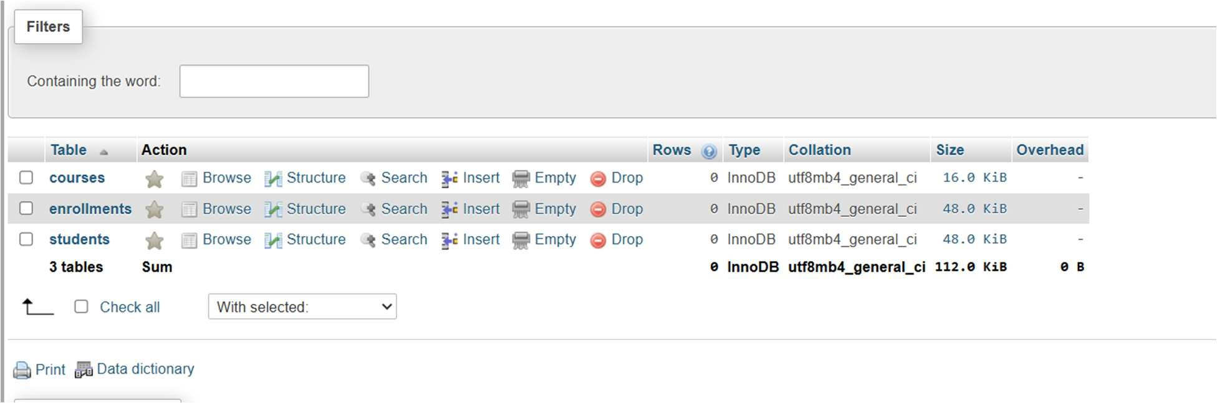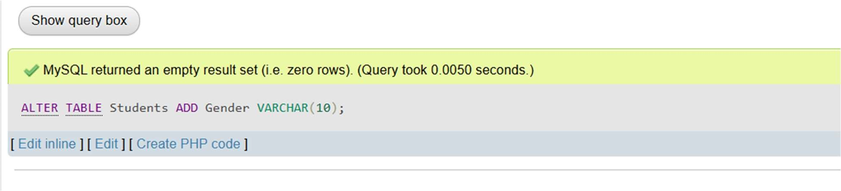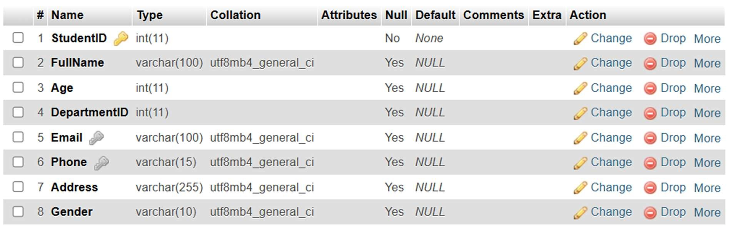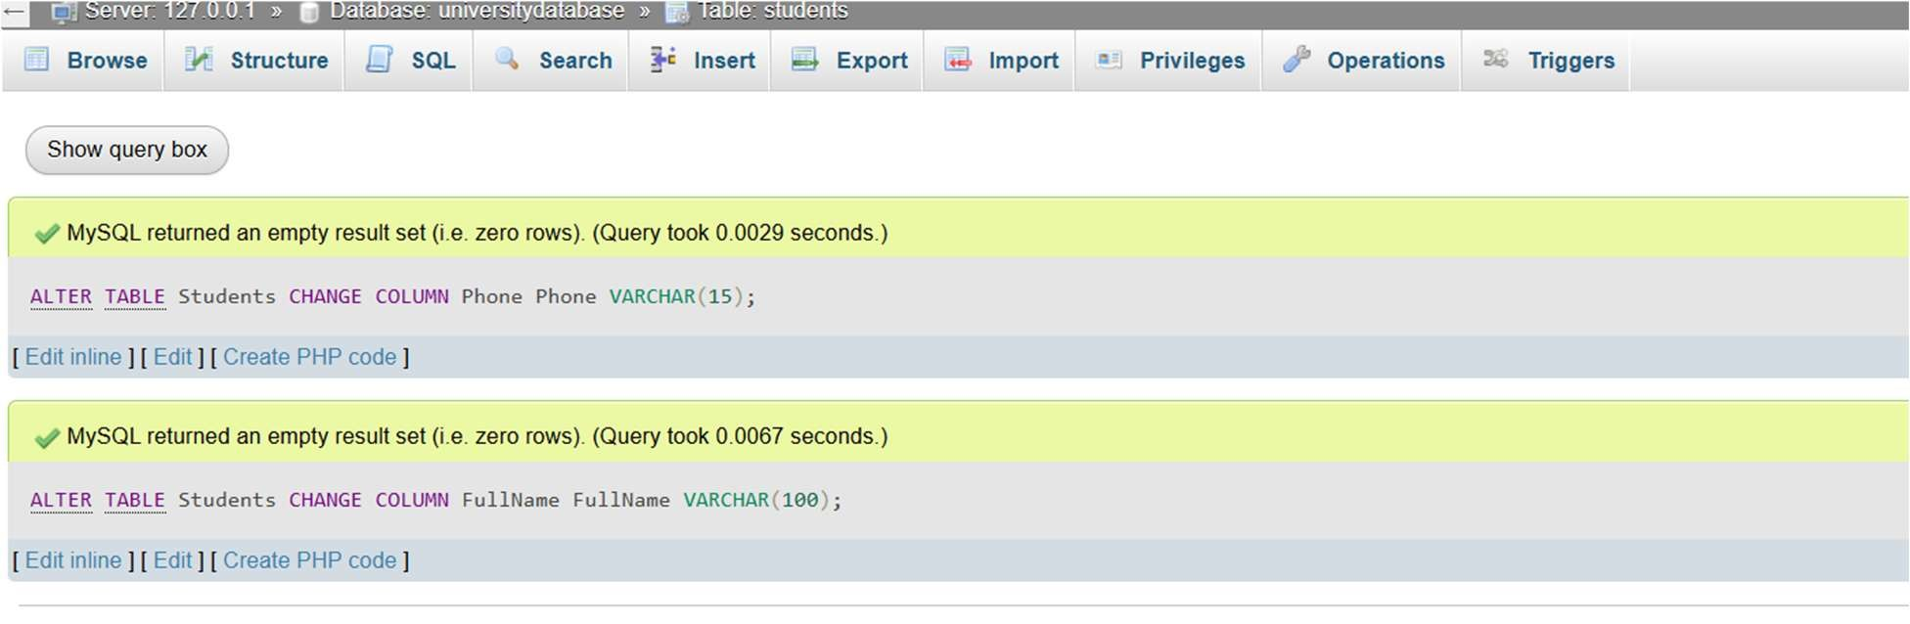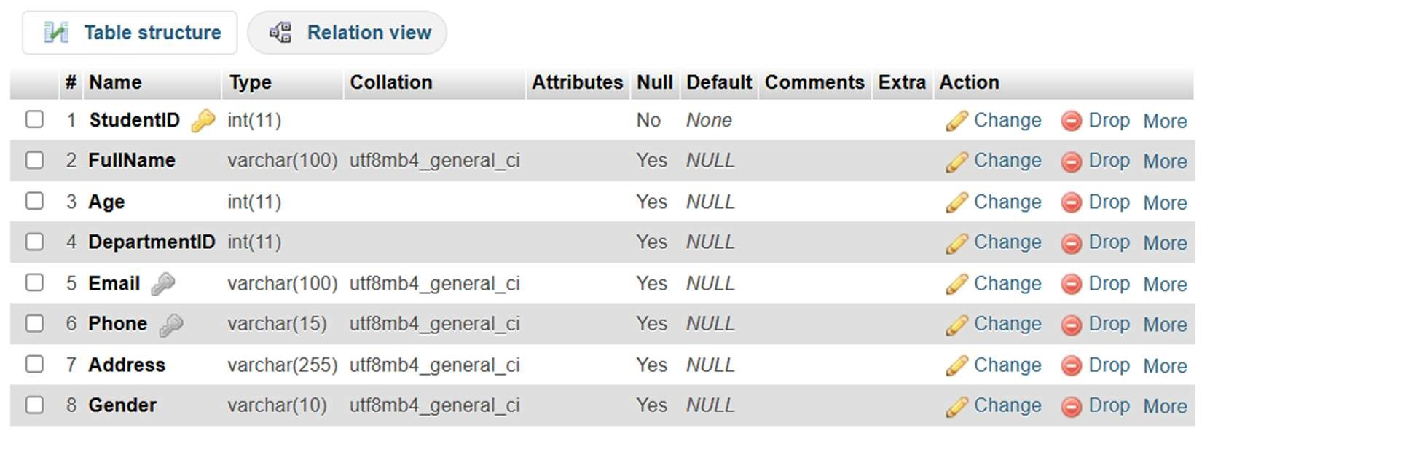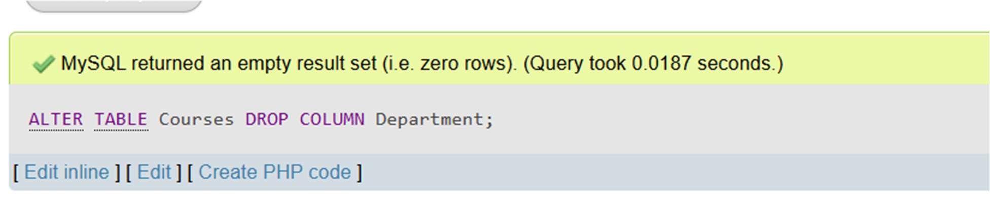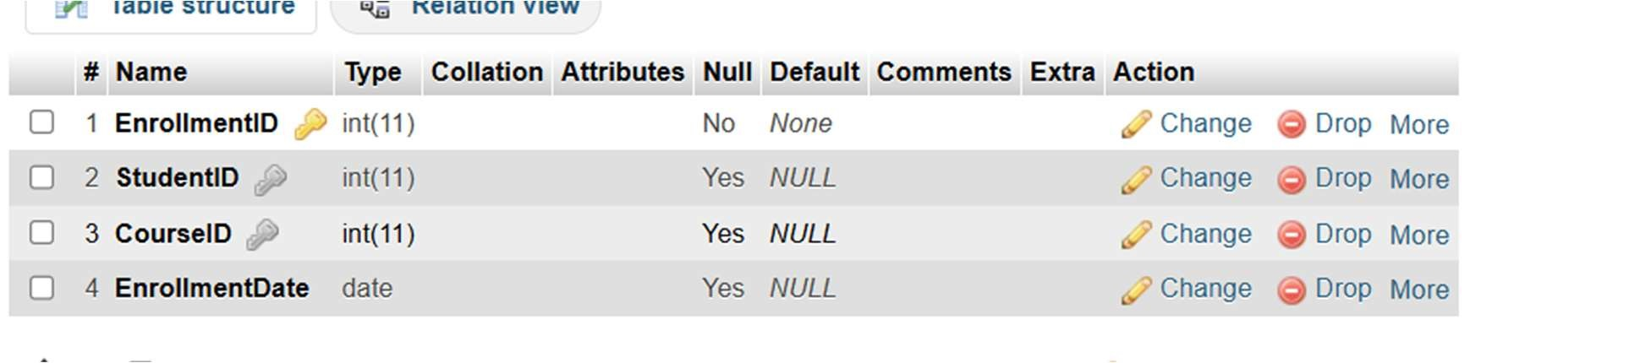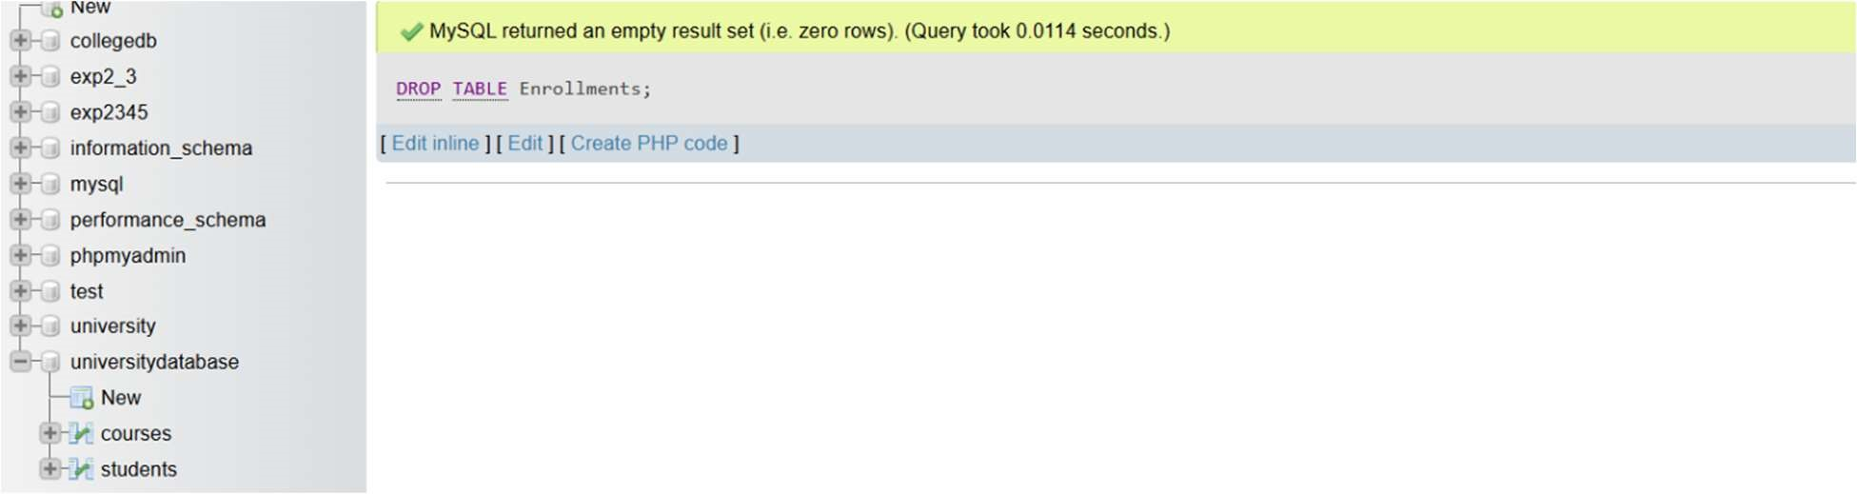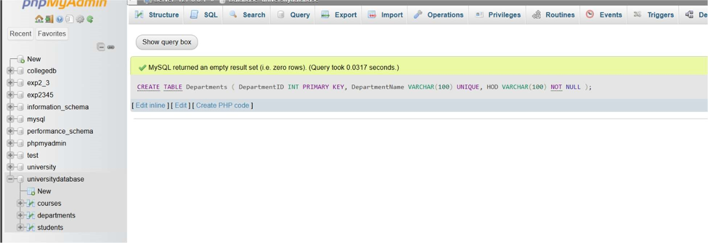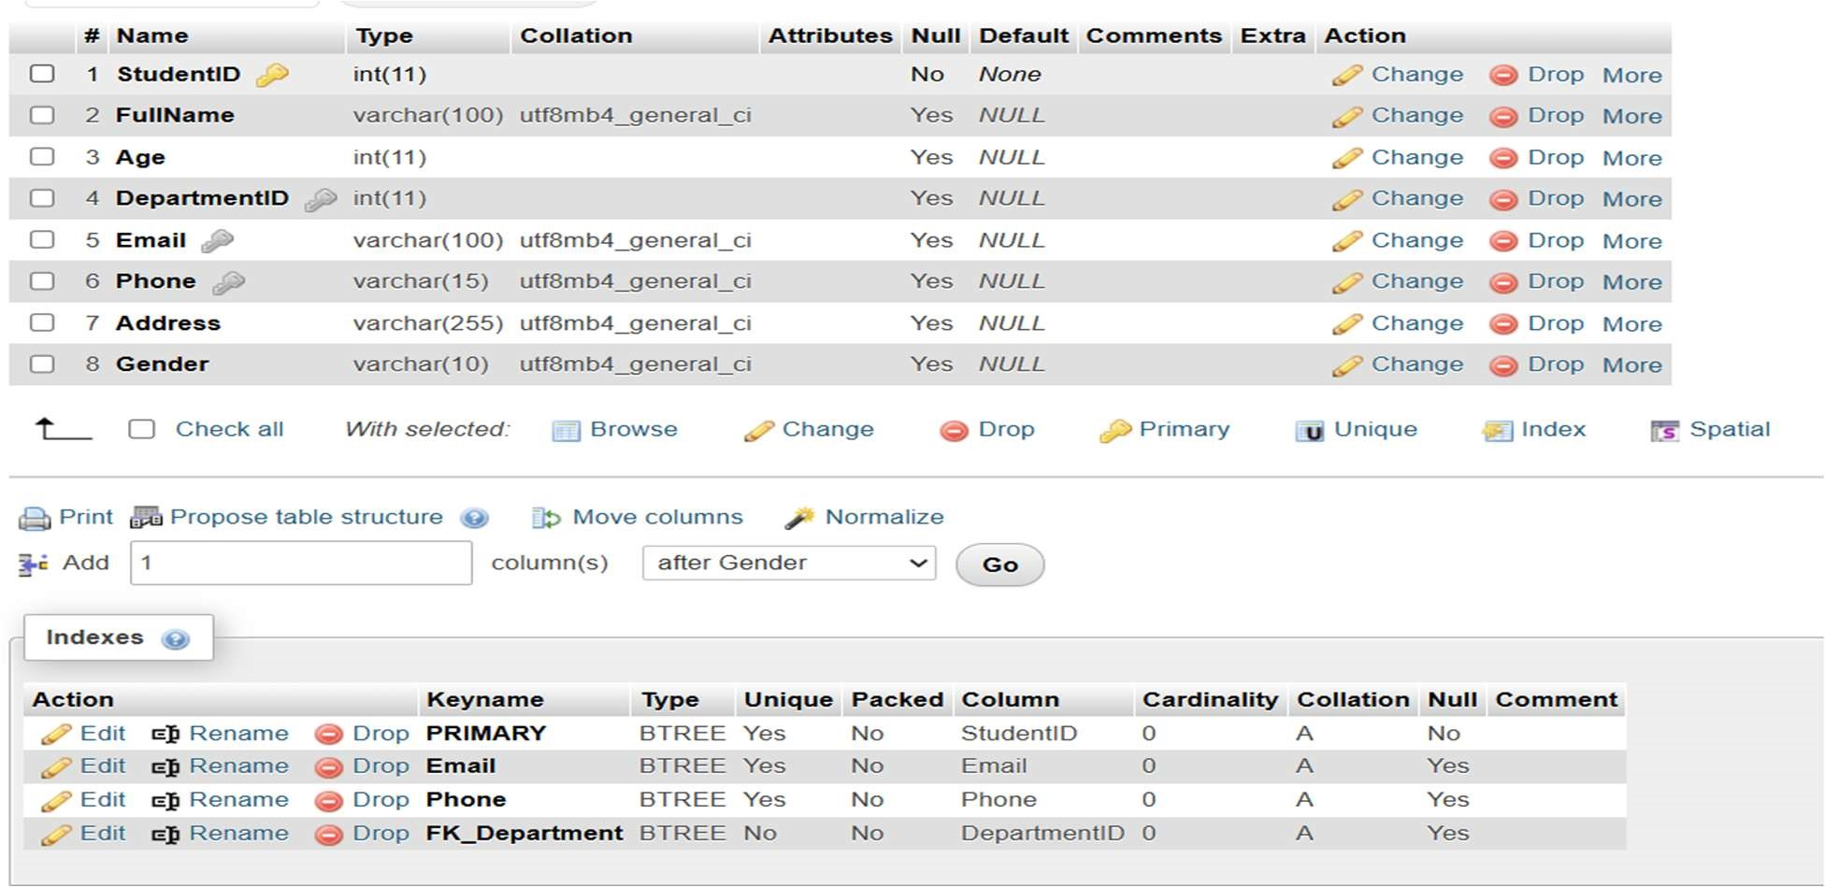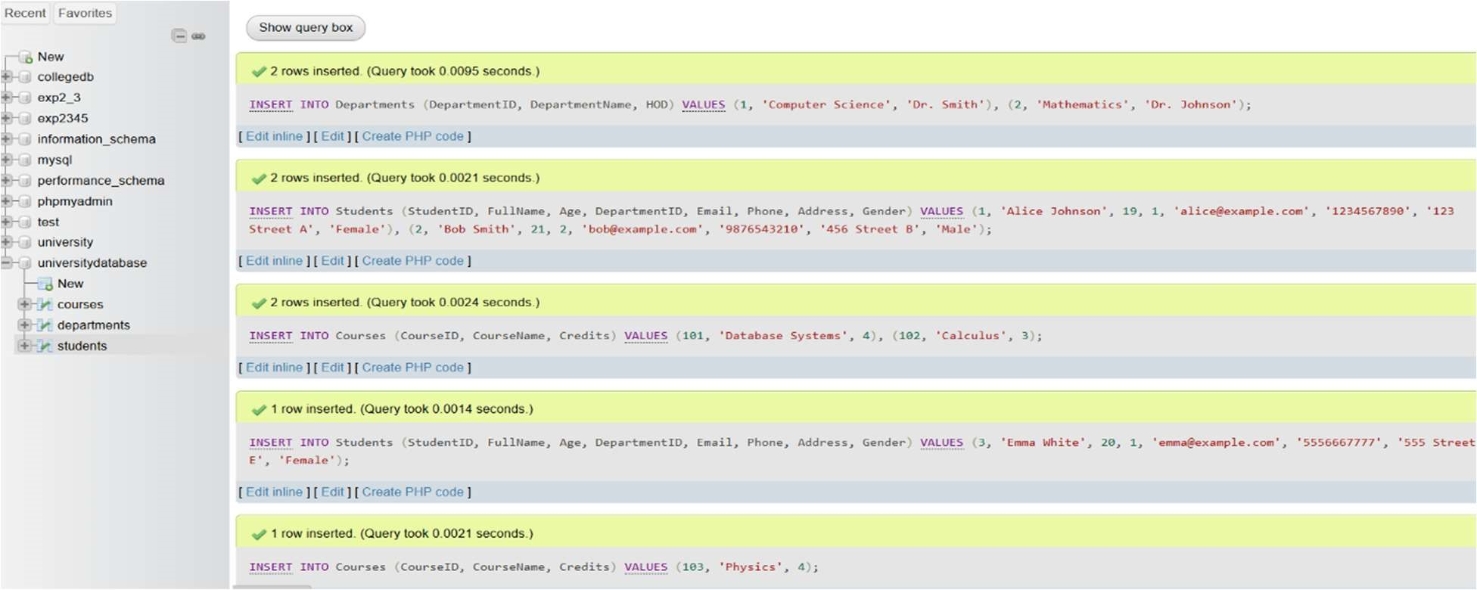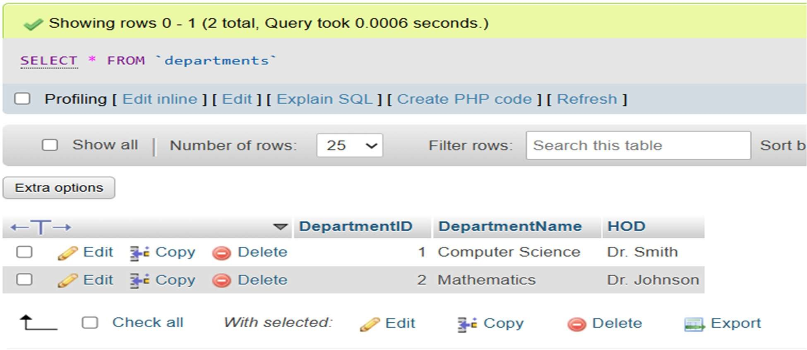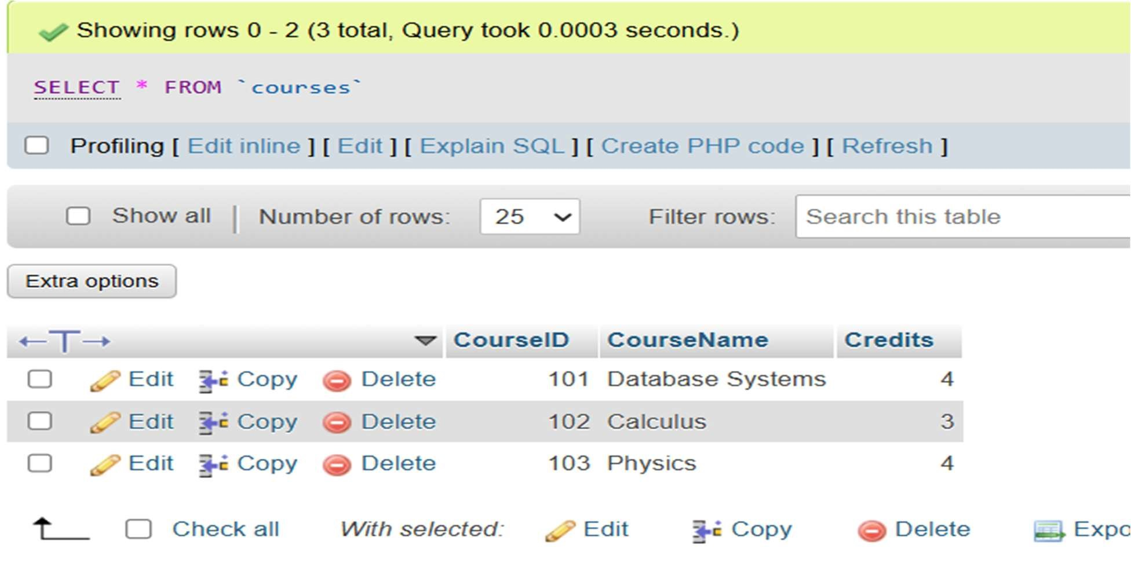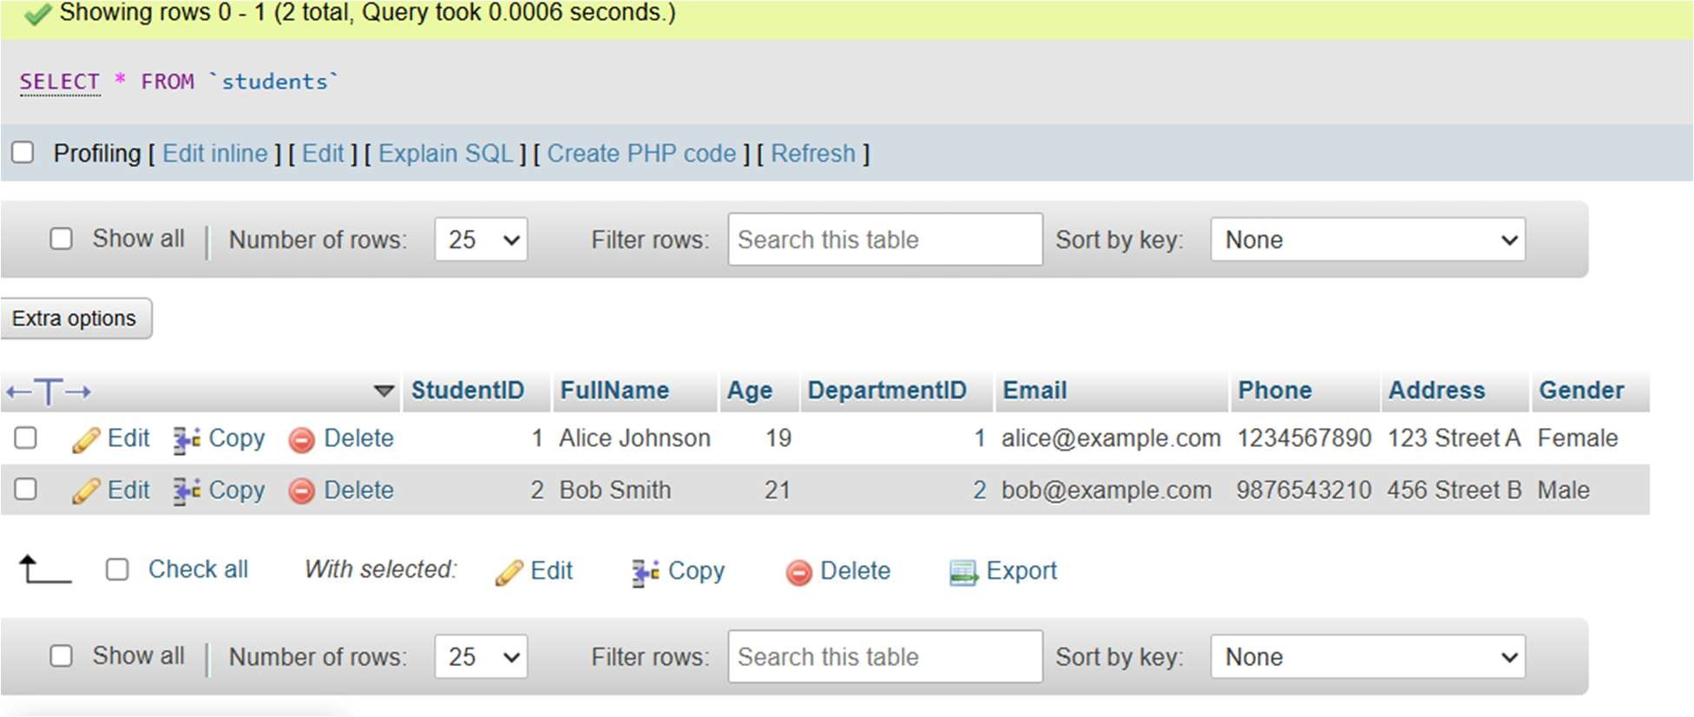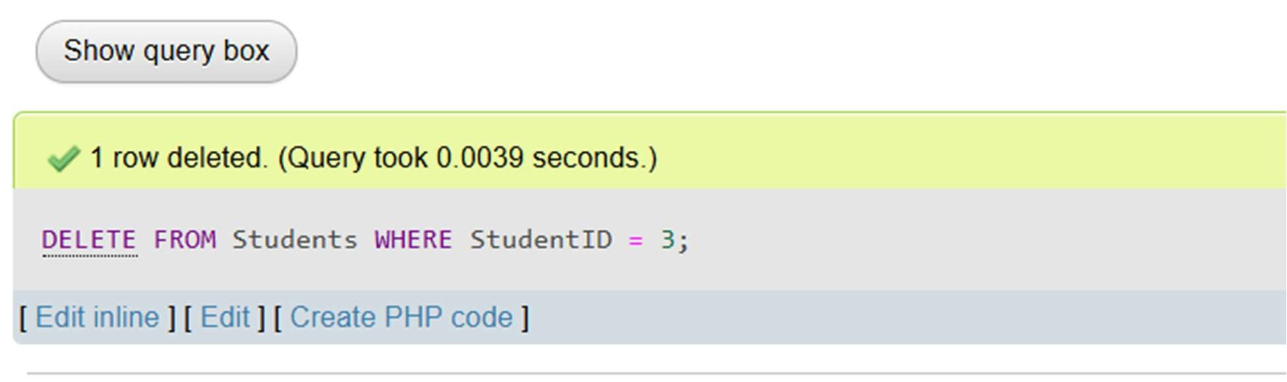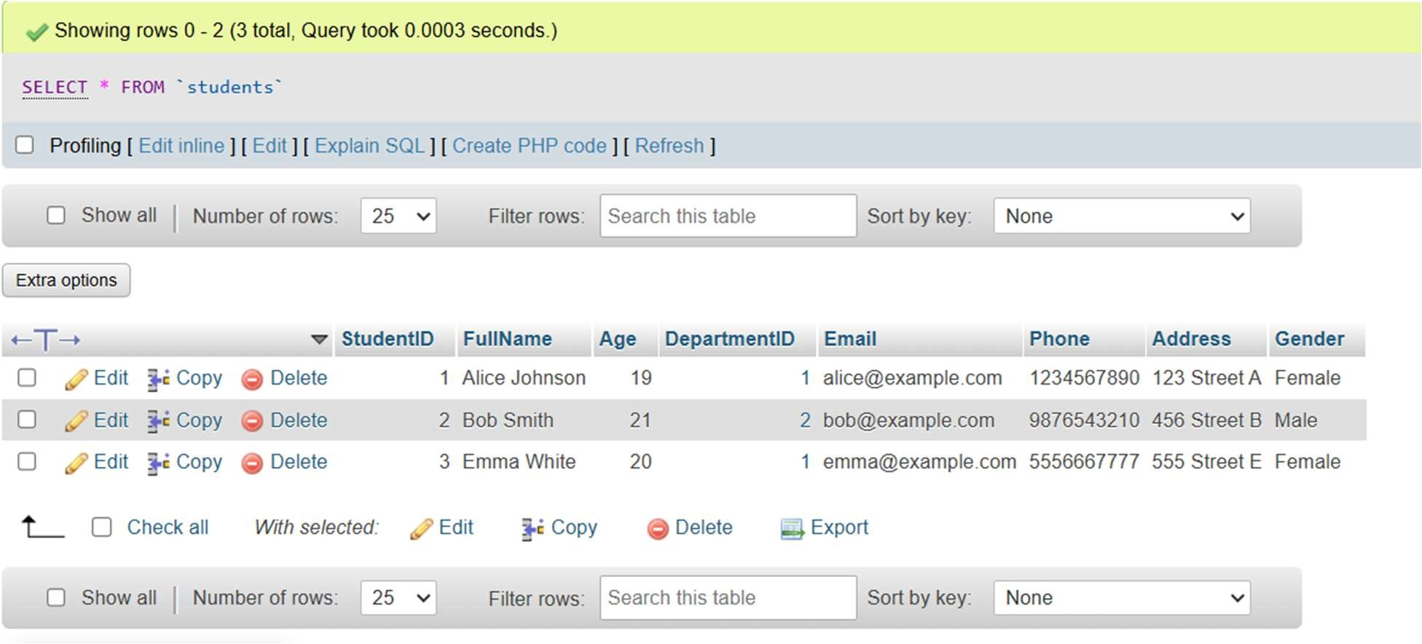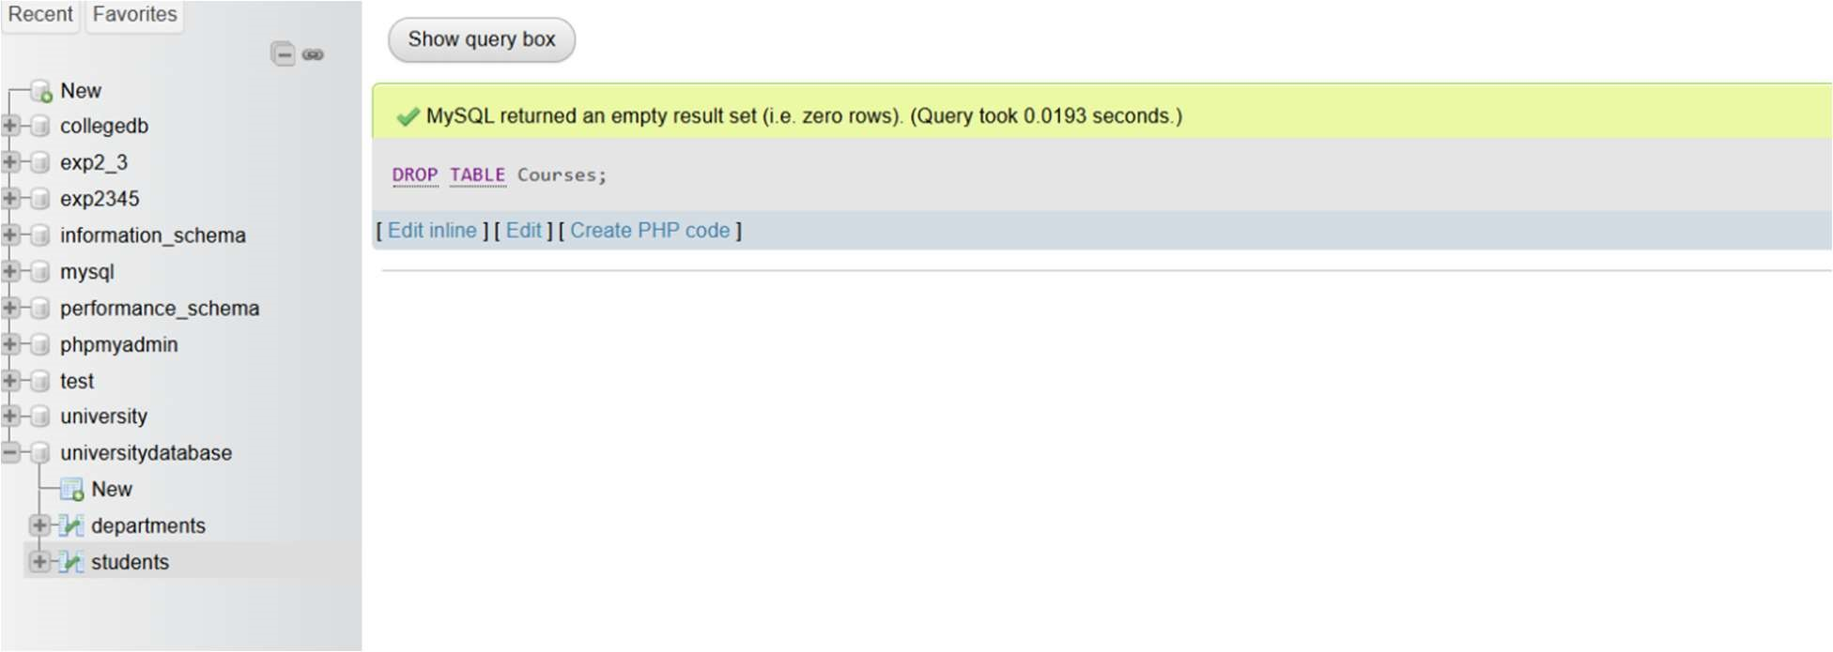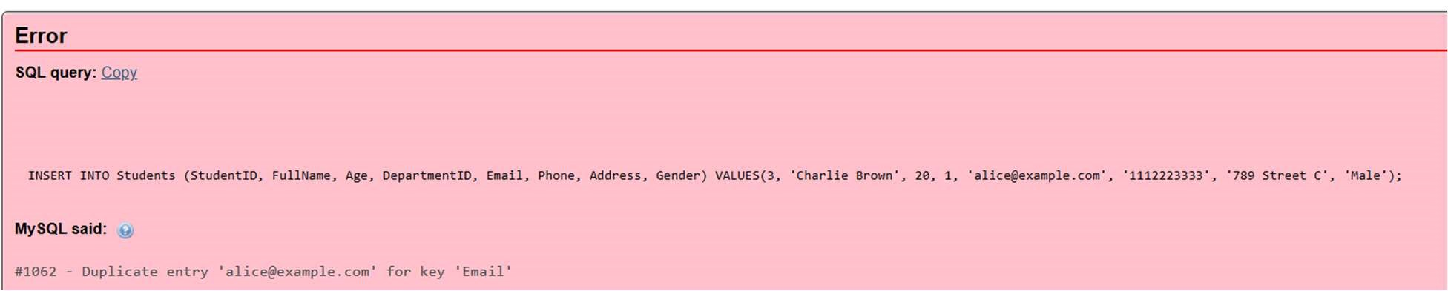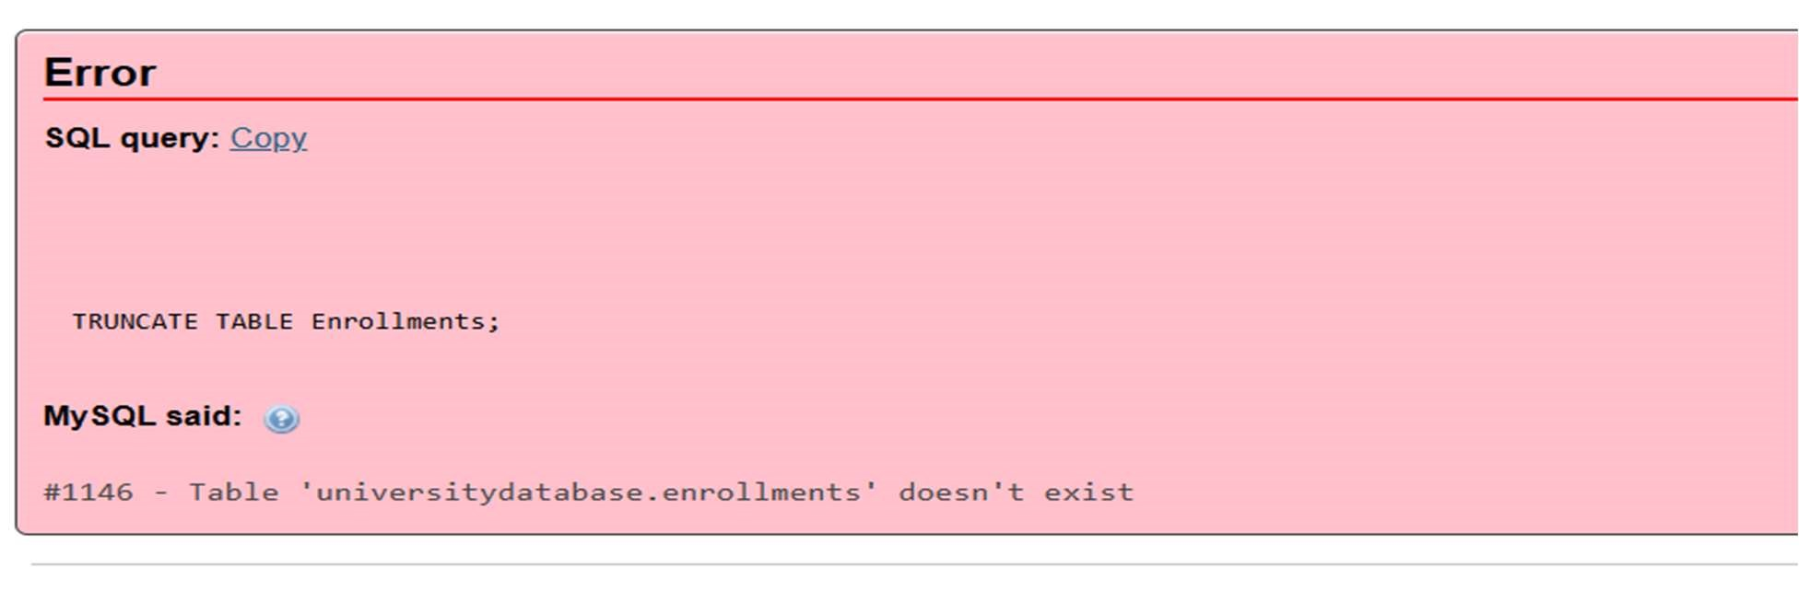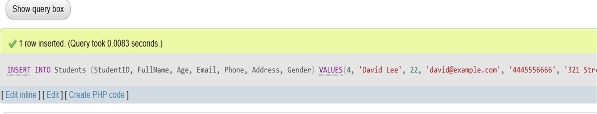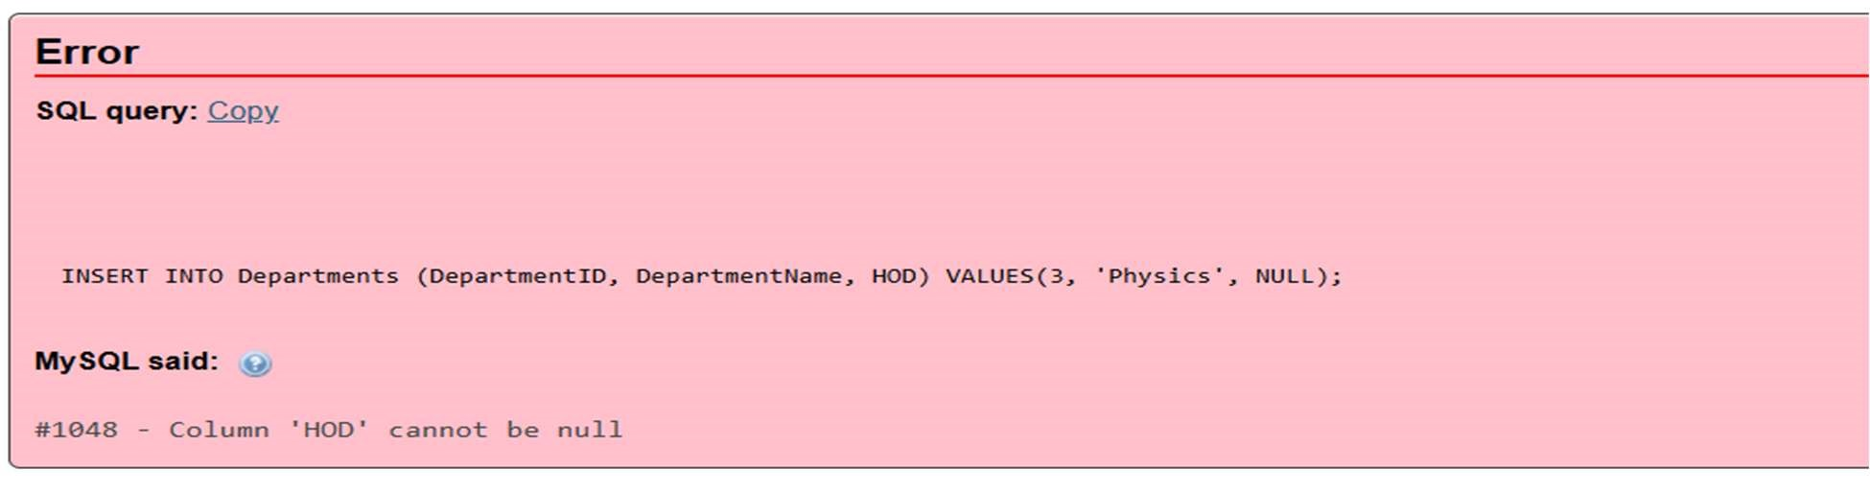

# EXPERIMENT2

Q1. Create the following tables:

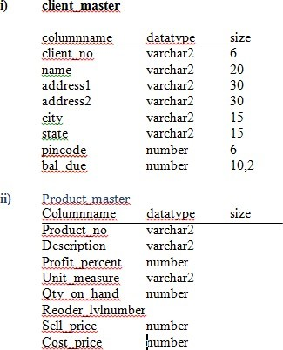

Q2- Insert the following data into their respective tables:

|  |  |  |  |  |  |
| --- | --- | --- | --- | --- | --- |
| Clien t No | Name | City | Pincode | State | Balance Due |
| 0001 | Ivan | Bombay | 400054 | Maharashtra | 15000 |
| 0002 | Vandana | Madras | 780001 | Tamilnadu | 0 |
| 0003 | Pramada | Bombay | 400057 | Maharashtra | 5000 |
| 0004 | Basu | Bombay | 400056 | Maharashtra | 0 |
| 0005 | Ravi | Delhi | 100001 |  | 2000 |
| 0006 | Rukmini | Bombay | 400050 | Maharashtra | 0 |

Data for Product Master:

|  |  |  |  |  |  |  |  |
| --- | --- | --- | --- | --- | --- | --- | --- |
| Product No. | Description | Profit  % | Unit  Measure | Qty_on_ hand | Reorder  _lvl | Selling  Price | Cost  Price |
| P00001 | 1.44floppies | 5 | piece | 100 | 20 | 525 | 500 |
| P03453 | Monitors | 6 | piece | 10 | 3 | 12000 | 11200 |
| P06734 | Mouse | 5 | piece | 20 | 5 | 1050 | 500 |
| P07865 | 1.22 floppies | 5 | piece | 100 | 20 | 525 | 500 |
| P07868 | Keyboards | 2 | piece | 10 | 3 | 3150 | 3050 |
| P07885 | CD Drive | 2.5 | piece | 10 | 3 | 5250 | 5100 |
| P07965 | 540 HDD | 4 | piece | 10 | 3 | 8400 | 8000 |
| P07975 | 1.44 Drive | 5 | piece | 10 | 3 | 1050 | 1000 |
| P08865 | 1.22 Drive | 5 | piece | 2 | 3 | 1050 | 1000 |

Q3: On the basis of the above two tables, answer the following questions:

1. Find out the names of all the clients.
2. Retrieve the list of names and cities of all the clients.
3. List the various products available from the product_master table.
4. List all the clients who are located in Bombay.
5. Display the information for client no 0001 and 0002.
6. Find the products with description as „1.44 drive‟ and „1.22 Drive‟.
7. Find all the products whose sell price is greater then 5000.
8. Find the list of all clients who stay in in city „Bombay‟ or city
9. „Delhi‟ or„Madras‟.
10. Find the product whose selling price is greater than 2000 and less than orequal to 5000.
11. List the name, city and state of clients not in the state of „Maharashtra‟.

Q4: Using the table client master and product master answer the followingQuestionnaires.

1. Change the selling price of „1.44 floppy drive to Rs.1150.00 2. Delete the record with client 0001 from the client master table.

1. Change the city of client_no‟0005‟ to Bombay.
2. Change the bal_due of client_no „0001, to 1000.
3. Find the products whose selling price is more than 1500 and also find the newselling price as original selling price *15.
4. Find out the clients who stay in a city whose second letter is a.
5. Find out the name of all clients having „a‟ as the second letter in their names.
6. List the products in sorted order of their description.
7. Count the total number of orders
8. Calculate the average price of all the products.
9. Calculate the minimum price of products.
10. Determine the maximum and minimum prices . Rename the tittle as „max_price‟and min_price respectively.
11. Count the number of products having price greater than or equal to 1500.

SQL QUERY

Create and Insert Data into the Following Tables

CREATE TABLE Client_Master (

Client_No VARCHAR(10) PRIMARY KEY,Name VARCHAR(50),

City VARCHAR(50),Pincode INT,

State VARCHAR(50),Balance_Due DECIMAL(10,2)

);

INSERT INTO Client_Master (Client_No, Name, City, Pincode, State, Balance_Due) VALUES

('0001', 'Ivan', 'Bombay', 400054, 'Maharashtra', 15000),

('0002', 'Vandana', 'Madras', 780001, 'Tamilnadu', 0),

('0003', 'Pramada', 'Bombay', 400057, 'Maharashtra', 5000),

('0004', 'Basu', 'Bombay', 400056, 'Maharashtra', 0),

('0005', 'Ravi', 'Delhi', 100001, NULL, 2000),

('0006', 'Rukmini', 'Bombay', 400050, 'Maharashtra', 0);

CREATE TABLE Product_Master (

Product_No VARCHAR(10) PRIMARY KEY, Description VARCHAR(50),

Profit_Percentage DECIMAL(5,2),Unit_Measure VARCHAR(20),

Qty_on_Hand INT,Reorder_Level INT,

Selling_Price DECIMAL(10,2),Cost_Price DECIMAL(10,2)

);

INSERT INTO Product_Master (Product_No, Description, Profit_Percentage, Unit_Measure,

Qty_on_Hand, Reorder_Level, Selling_Price, Cost_Price) VALUES

('P00001', '1.44floppies', 5, 'piece', 100, 20, 525, 500),

('P03453', 'Monitors', 6, 'piece', 10, 3, 12000, 11200),

('P06734', 'Mouse', 5, 'piece', 20, 5, 1050, 500),

('P07865', '1.22 floppies', 5, 'piece', 100, 20, 525, 500),

('P07868', 'Keyboards', 2, 'piece', 10, 3, 3150, 3050),

('P07885', 'CD Drive', 2.5, 'piece', 10, 3, 5250, 5100),

('P07965', '540 HDD', 4, 'piece', 10, 3, 8400, 8000),

('P07975', '1.44 Drive', 5, 'piece', 10, 3, 1050, 1000),

('P08865', '1.22 Drive', 5, 'piece', 2, 3, 1050, 1000);

Q3

1. SELECT Name FROM Client_Master;

1. SELECT Name, City FROM Client_Master;

1. SELECT Description FROM Product_Master;

1. SELECT * FROM Client_Master WHERE City = 'Bombay';

1. SELECT * FROM Client_Master WHERE Client_No IN ('0001', '0002');

1. SELECT * FROM Product_Master WHERE Description IN ('1.44 Drive', '1.22 Drive');

1. SELECT * FROM Product_Master WHERE Selling_Price > 5000;

1. SELECT * FROM Client_Master WHERE City IN ('Bombay', 'Delhi', 'Madras');

1. SELECT * FROM Product_Master WHERE Selling_Price > 2000 AND Selling_Price <= 5000;

1. SELECT Name, City, State FROM Client_Master WHERE State <> 'Maharashtra' OR State IS NULL;

Q4

1)UPDATE product_master SET selling_price = 1150.00 WHERE description = '1.44floppies';

2)DELETE FROM client_master WHERE client_no = '0001';

3)UPDATE client_master SET city = 'Bombay' WHERE client_no = '0005';

4)UPDATE client_master SET balance_due = 1000 WHERE client_no = '0001';

5)SELECT product_no, description, selling_price, (selling_price * 15) AS new_selling_priceFROM product_masterWHERE selling_price > 1500;

6)SELECT * FROM client_master WHERE city LIKE '_a%';

7)SELECT * FROM client_master WHERE name LIKE '_a%';

8)SELECT * FROM product_master ORDER BY description ASC;

9)SELECT COUNT(*) AS total_orders FROM sales_order;

10)SELECT AVG(selling_price) AS average_price FROM product_master;

11)SELECT MIN(selling_price) AS min_price FROM product_master;

12)SELECT MAX(selling_price) AS max_price, MIN(selling_price) AS min_price FROM product_master;

13)SELECT COUNT(*) AS product_count FROM product_master WHERE selling_price >= 1500;

OUTPUT

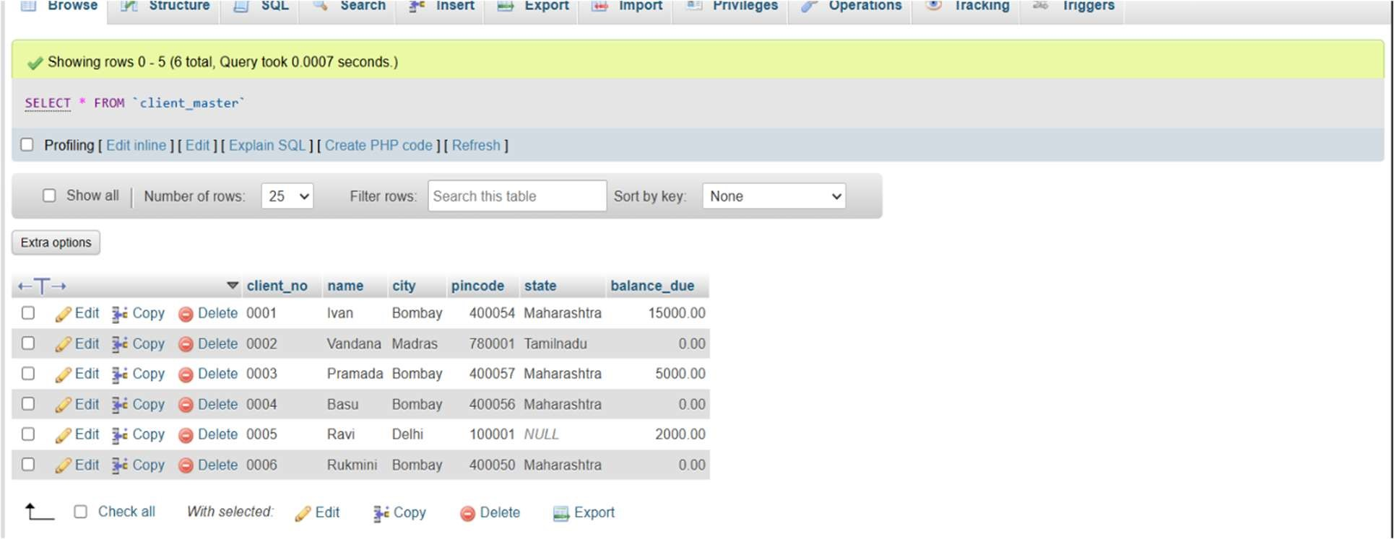

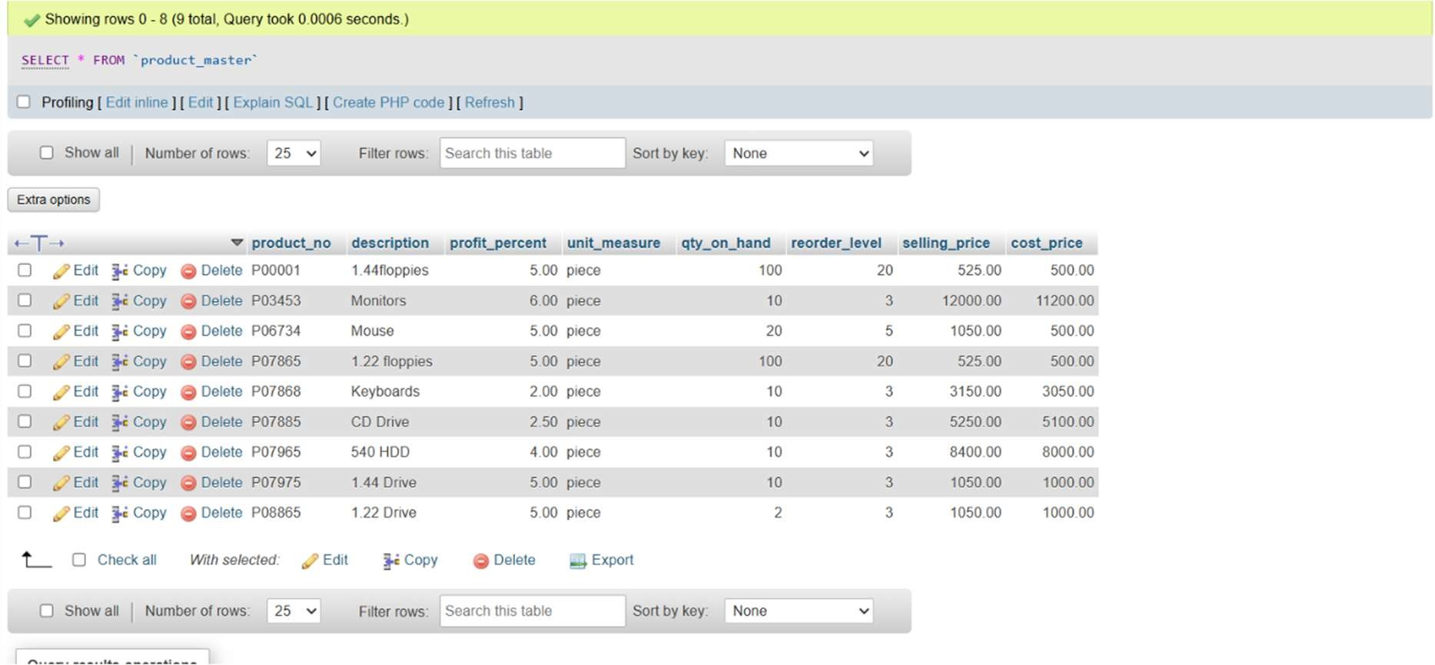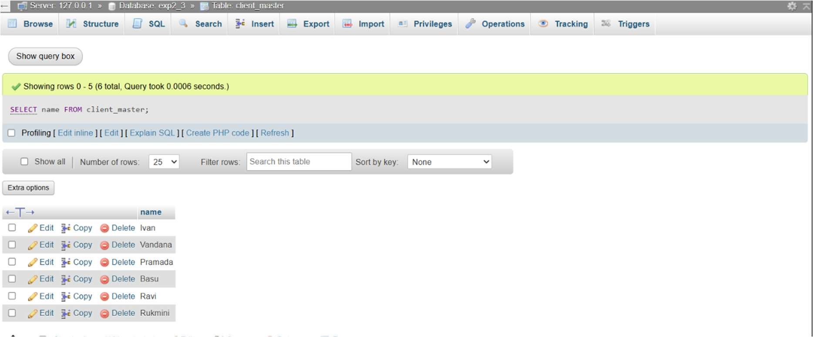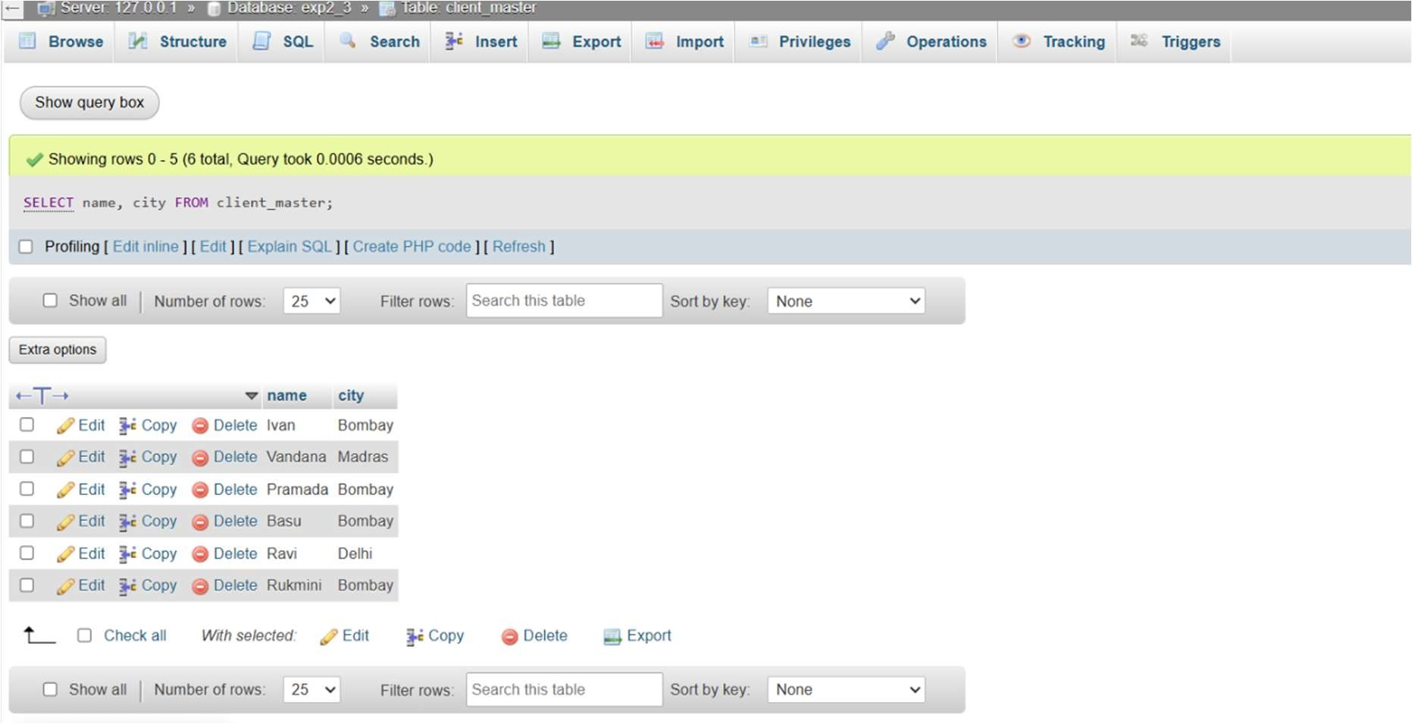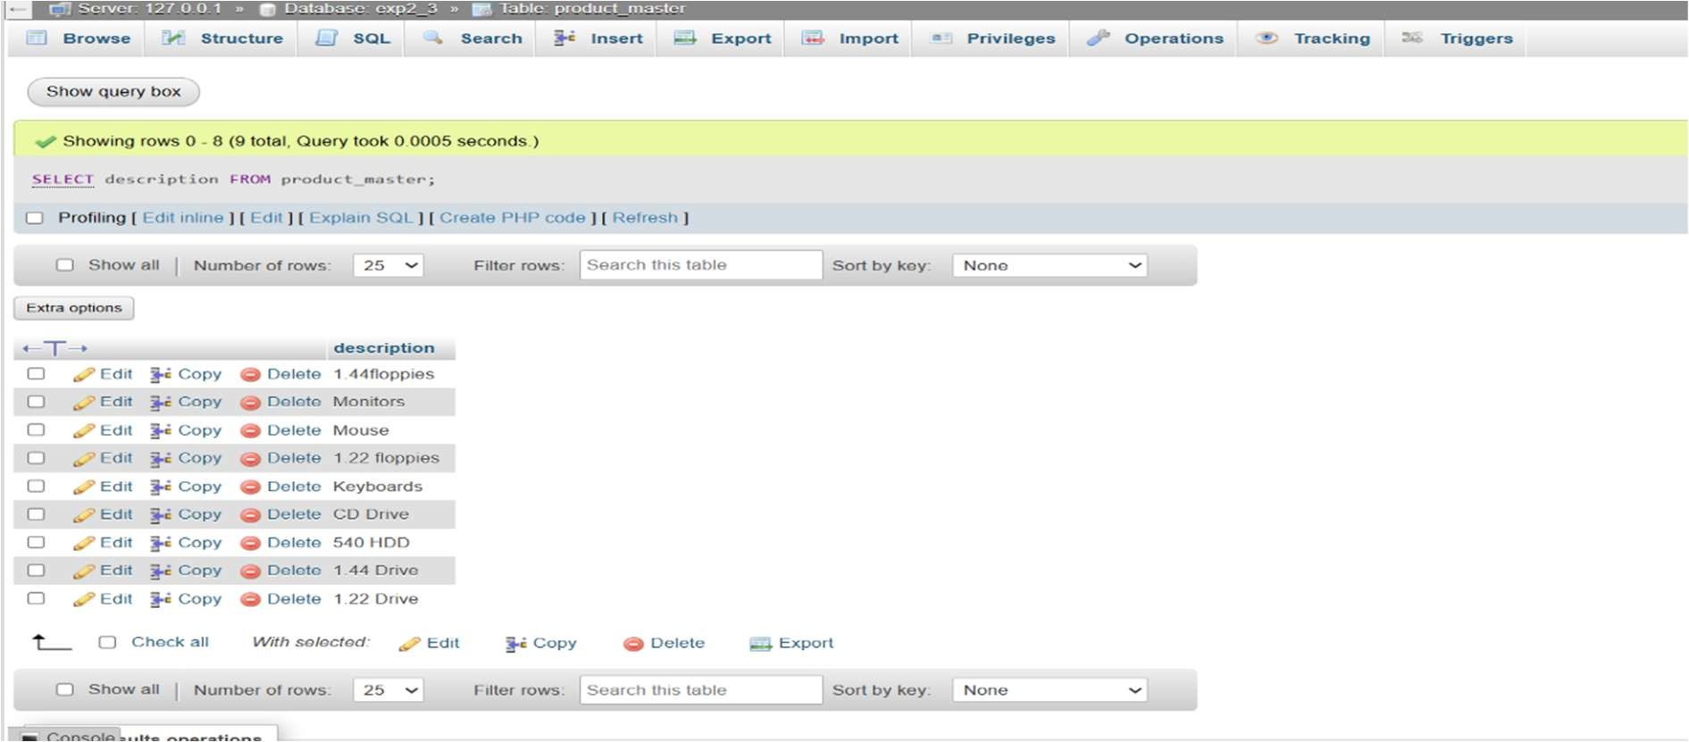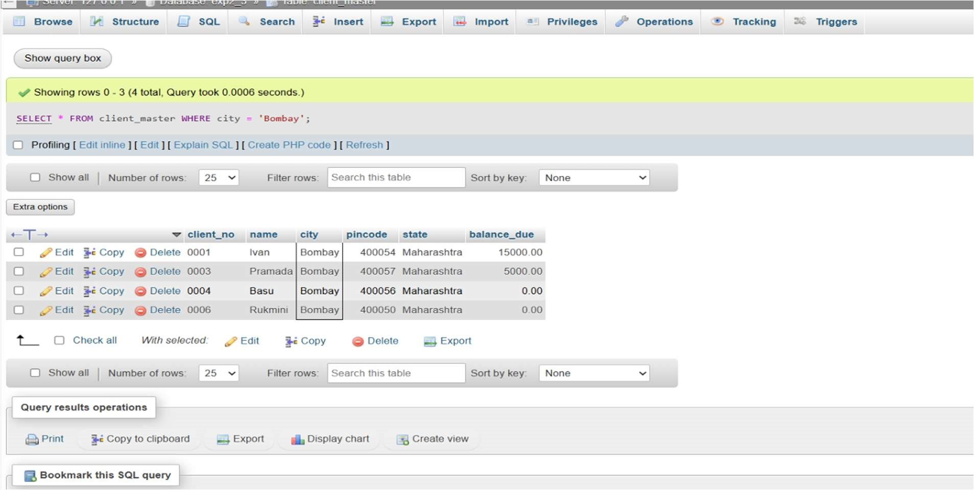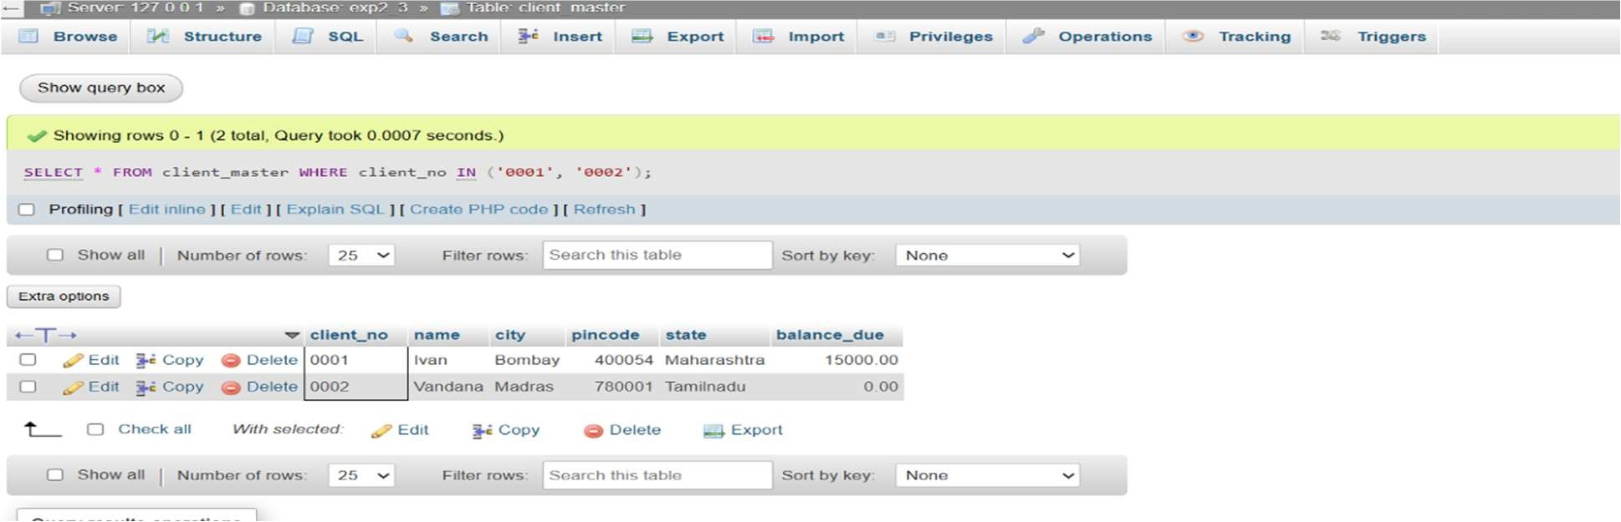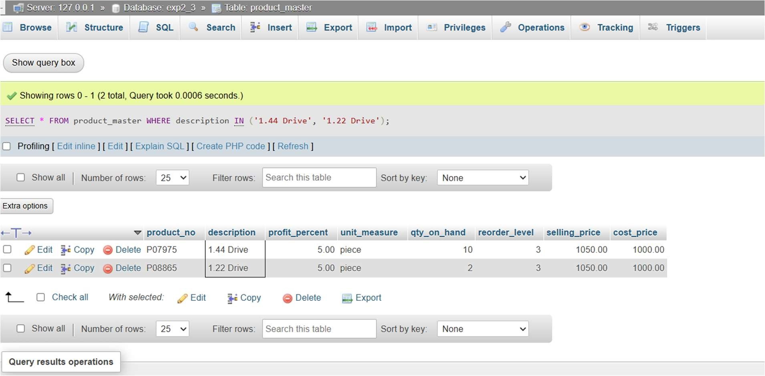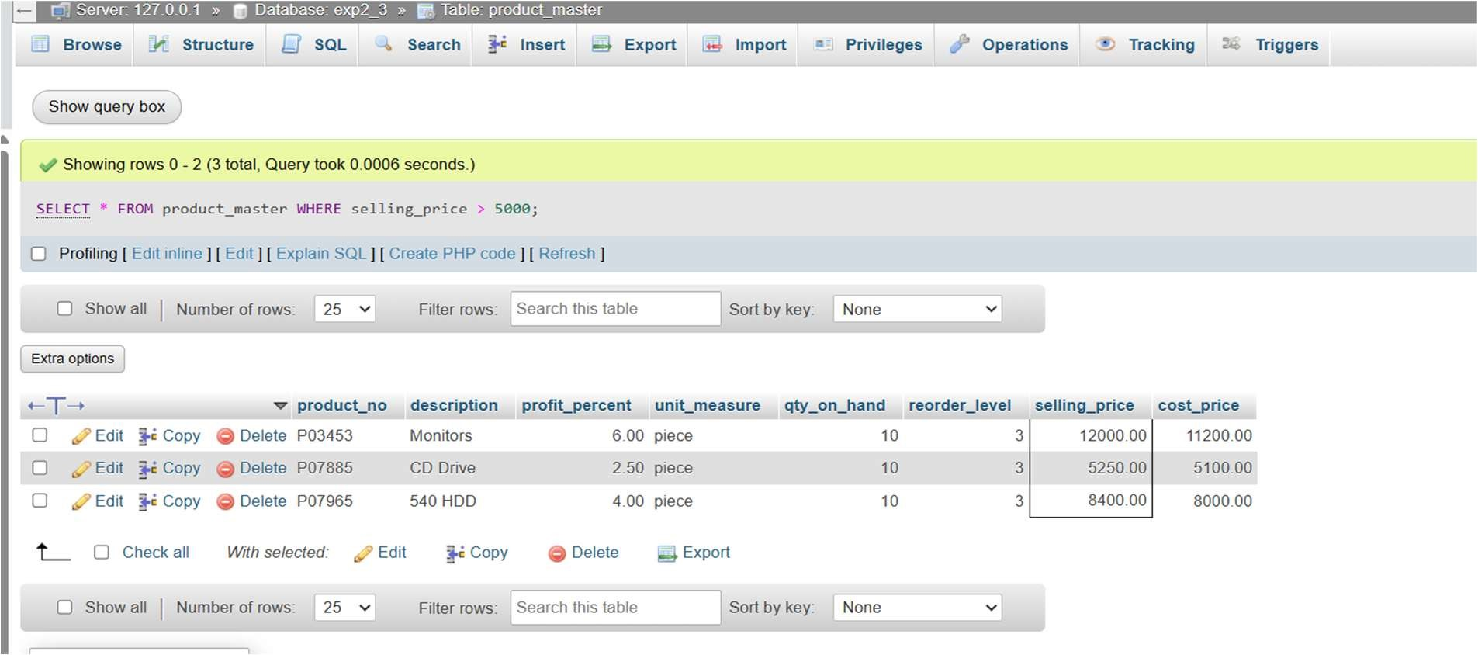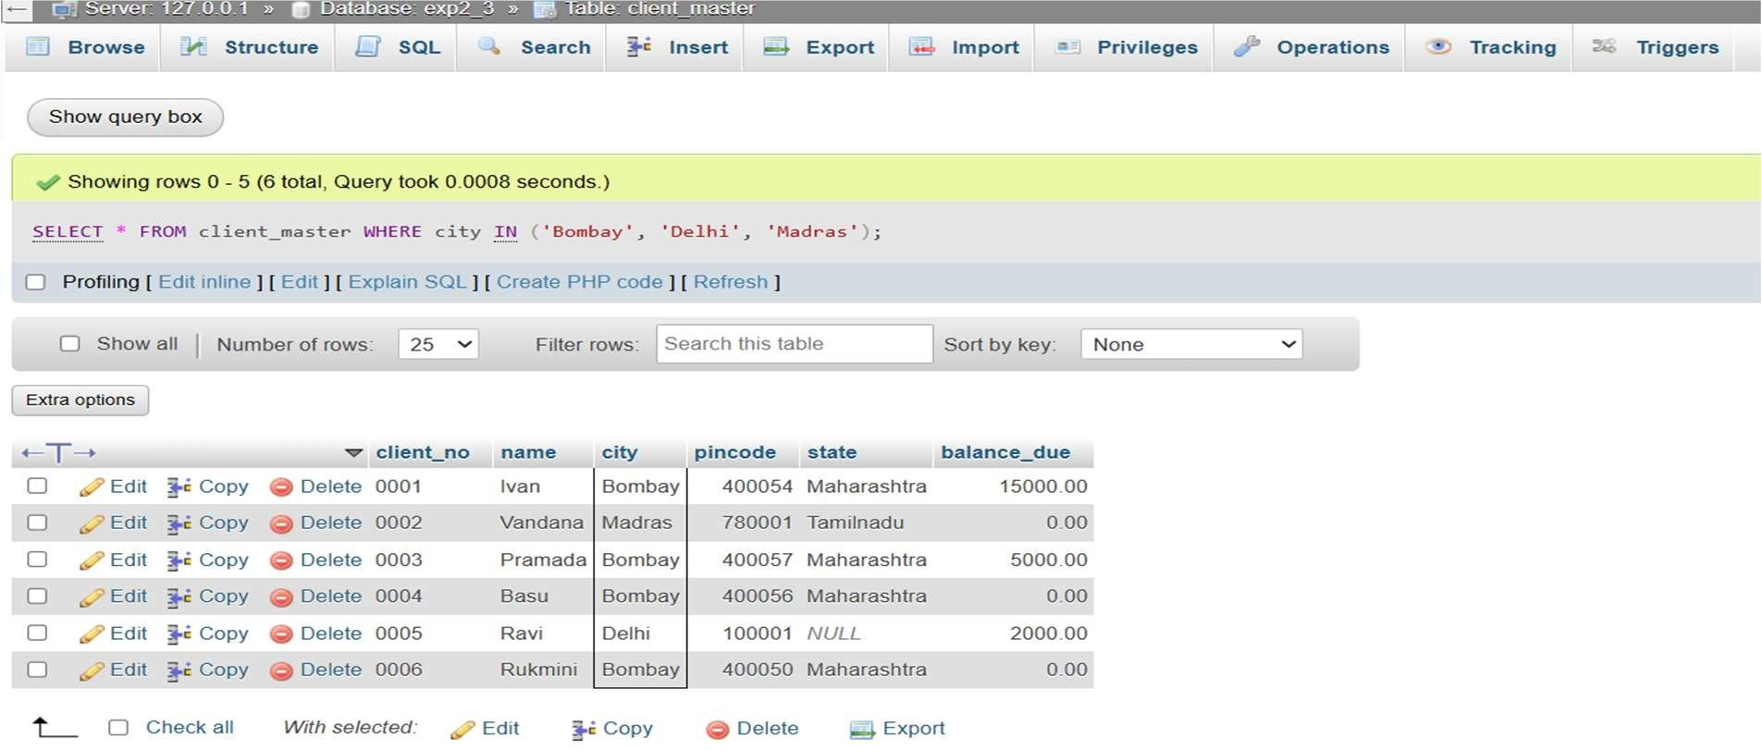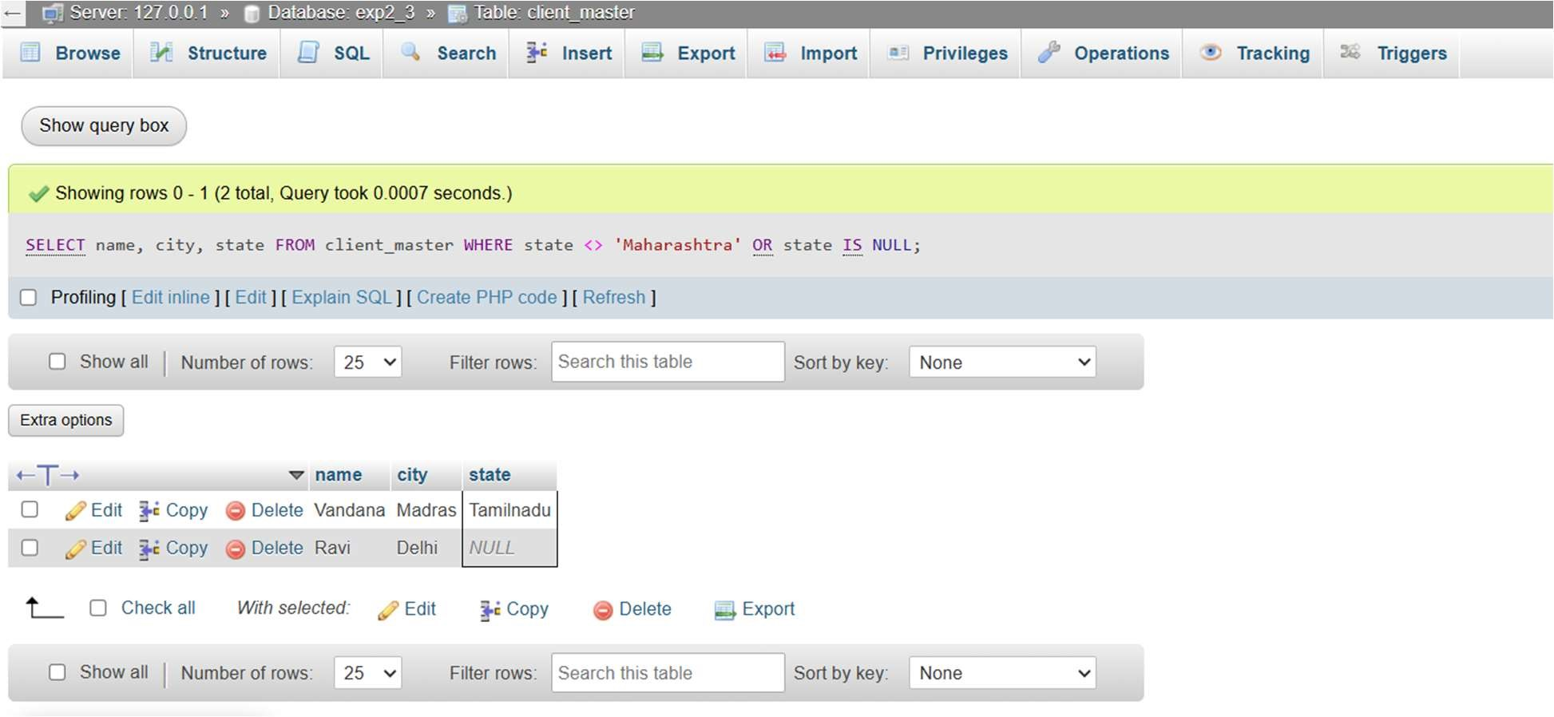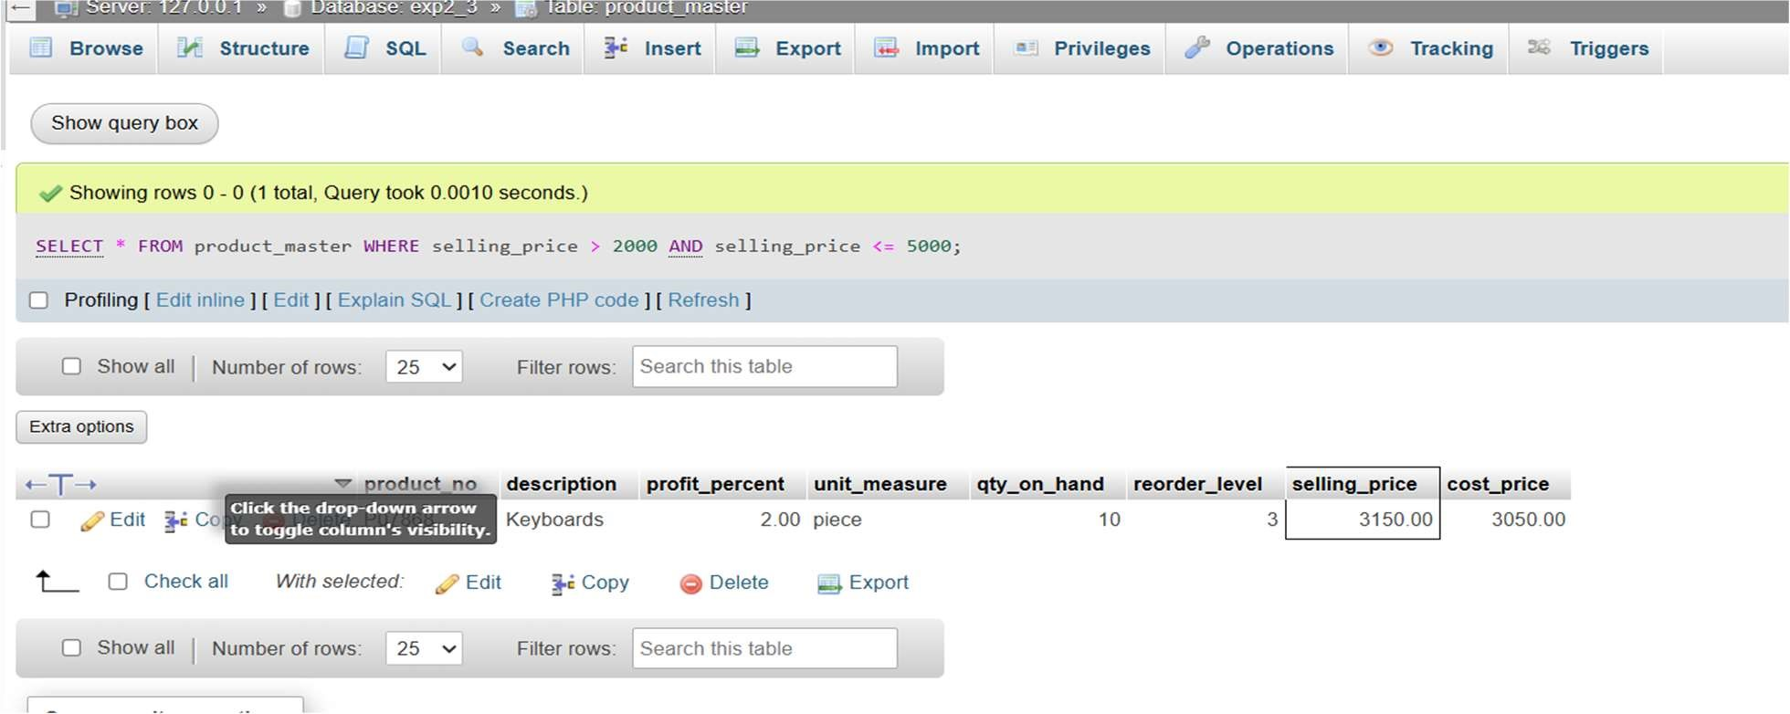

Q4.

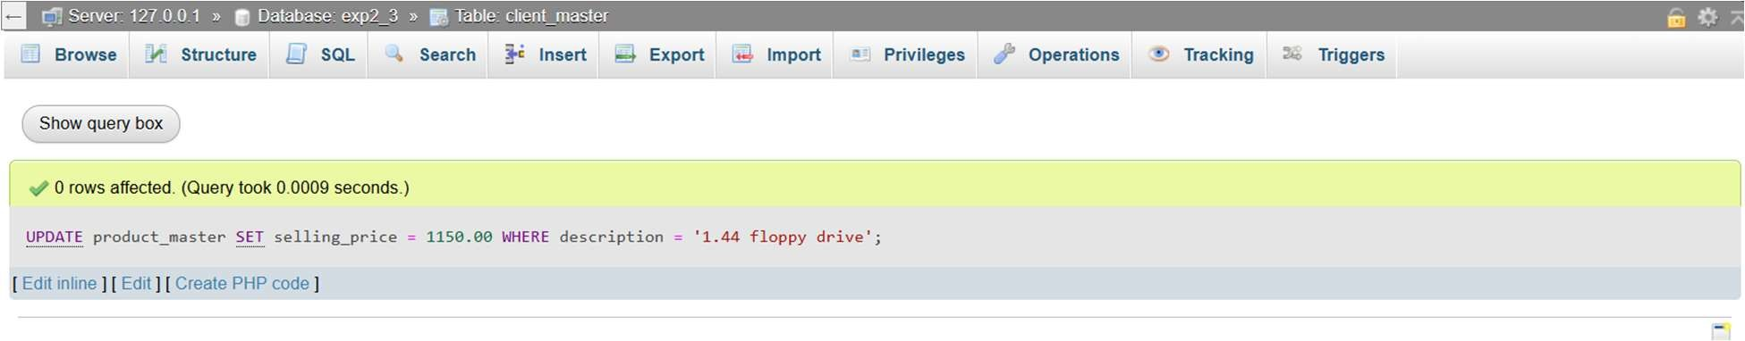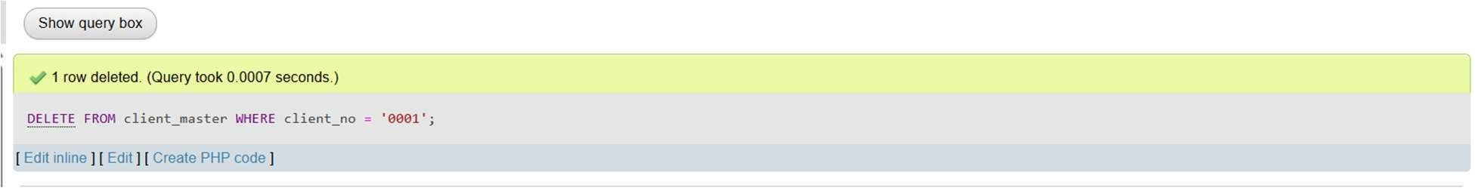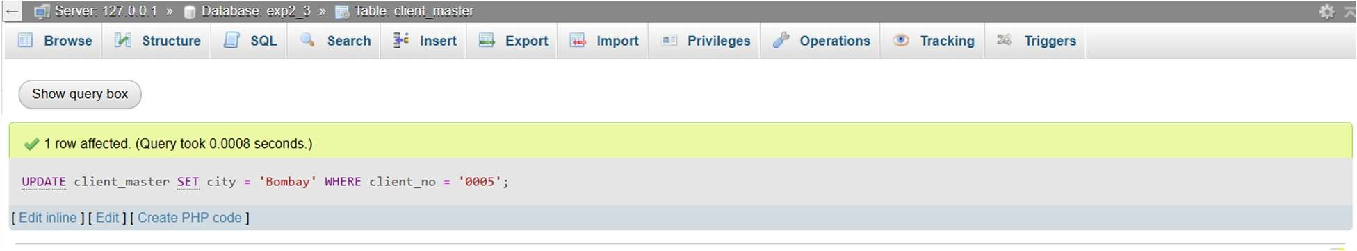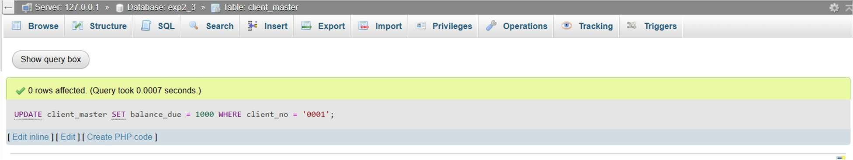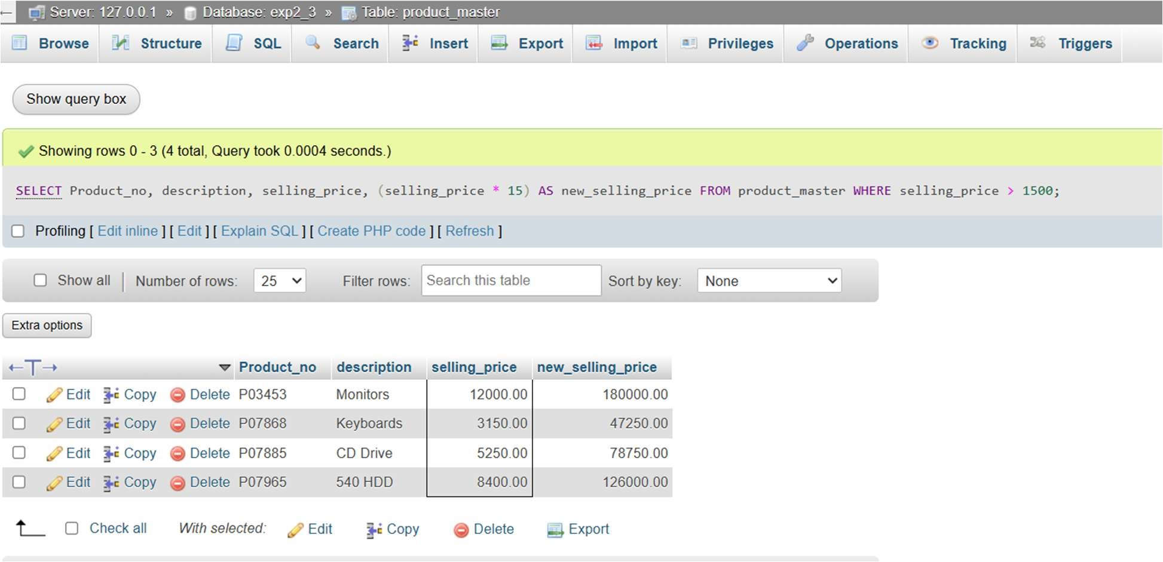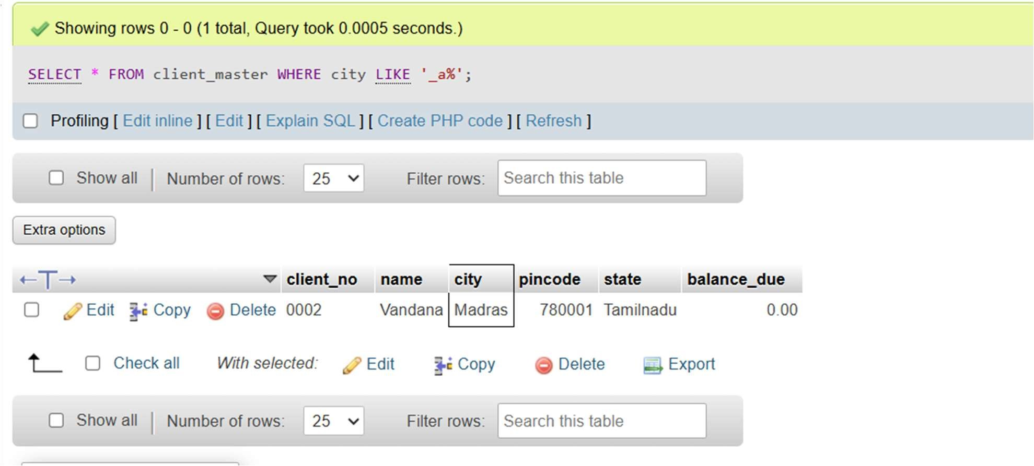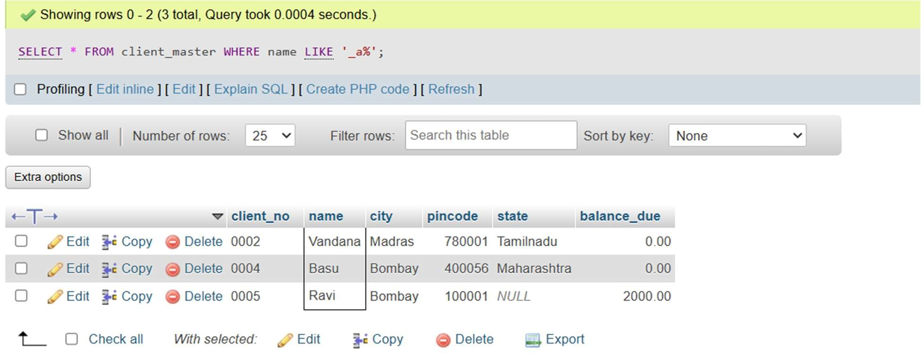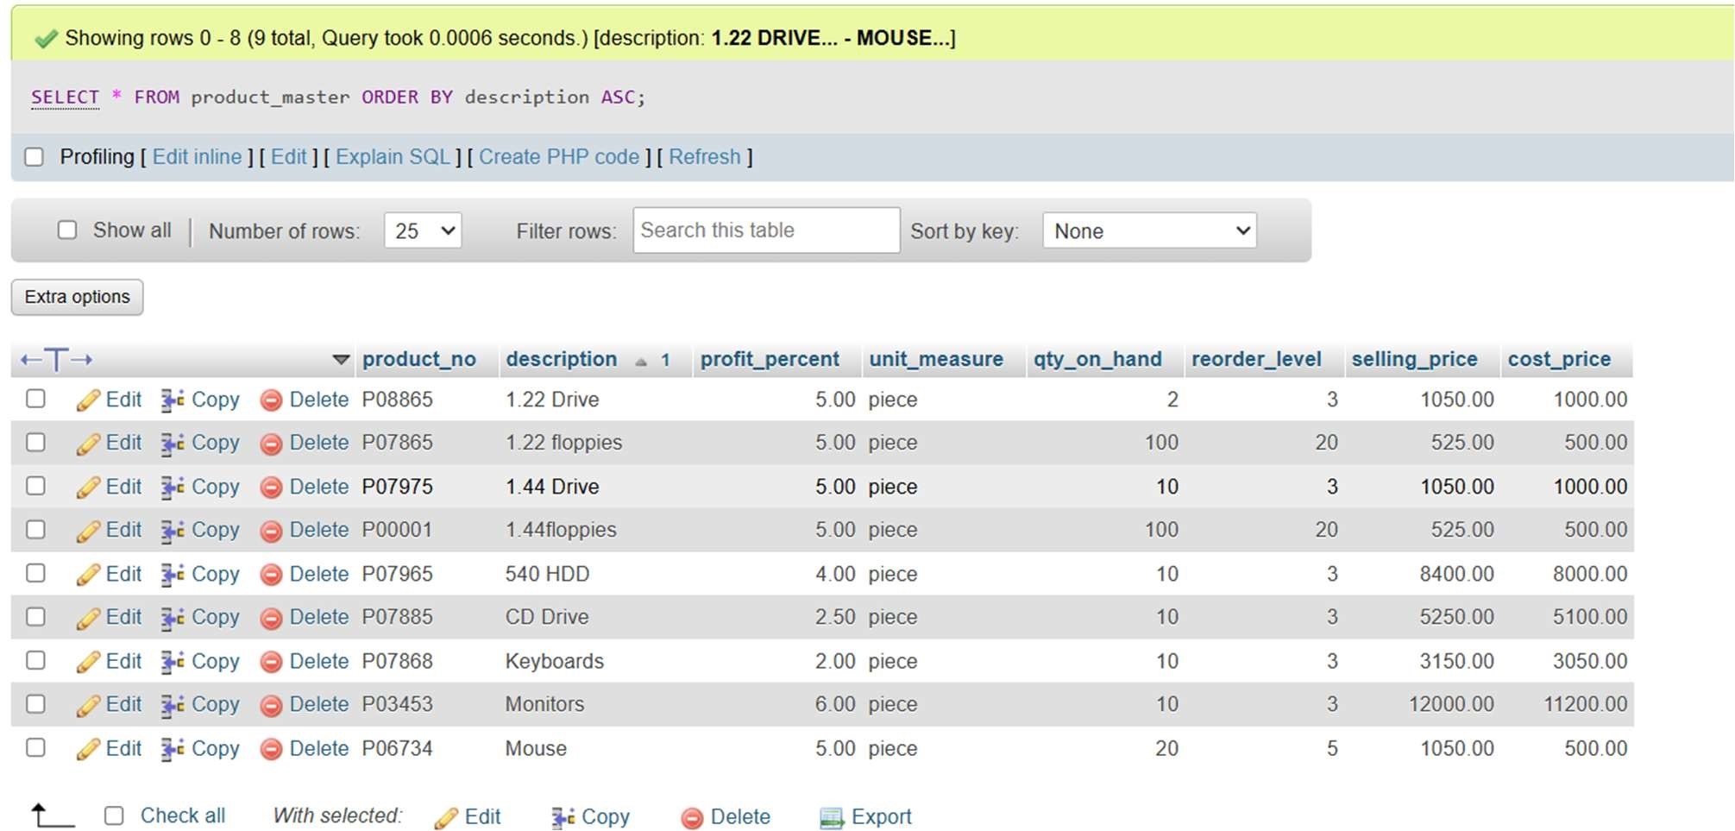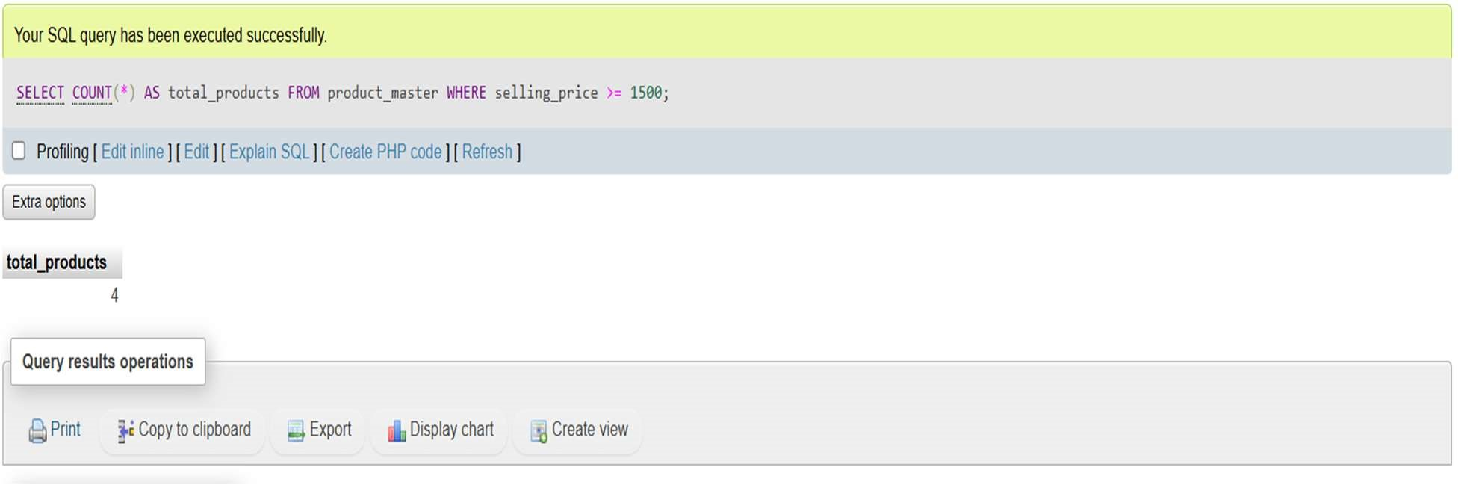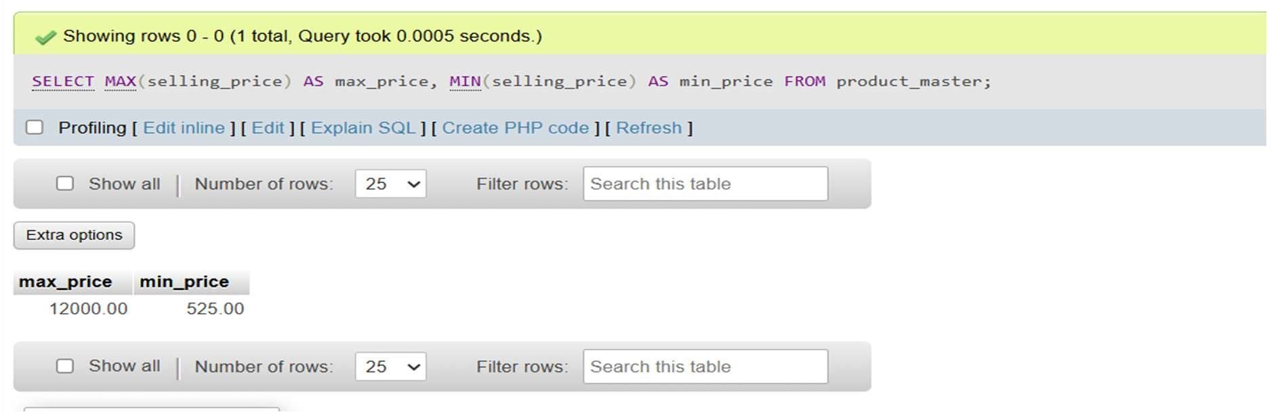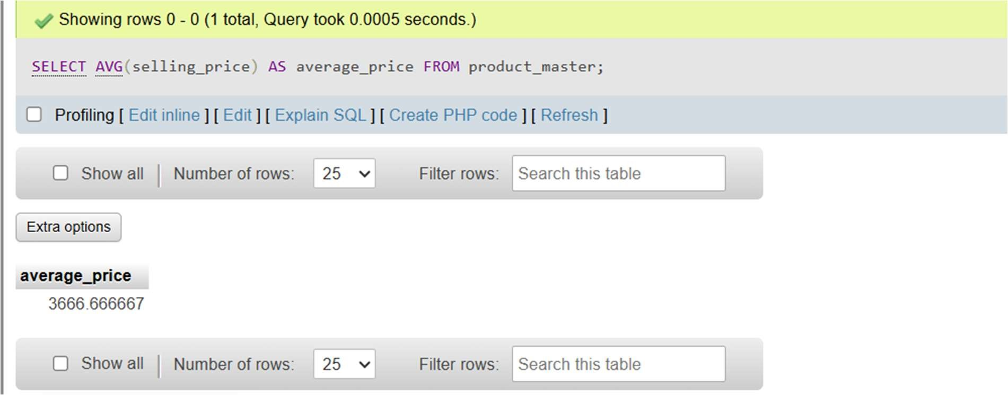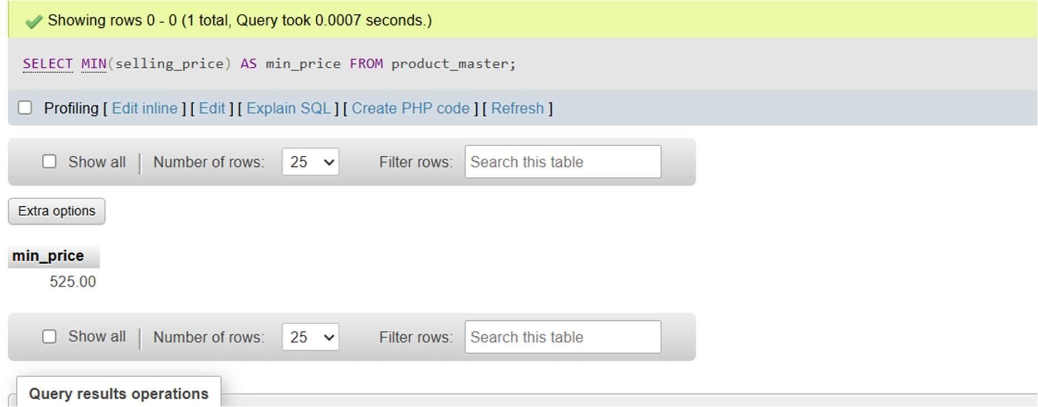

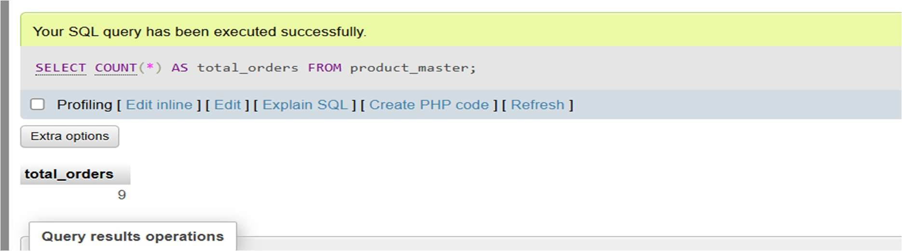

# EXPERIMENT3

Q1. Create a database called CollegeDB and design the following tables:

Student (student_id, name, age, gender, department),

Course (course_id, course_name, credits),

Enrollment (student_id, course_id, enrollment_date)

Write SQL queries for the following:

1. Insert records into the tables.
2. Retrieve the list of students who are enrolled in a particular course.
3. Find the number of students in each department.

Q2. Consider the following two tables:

Employee (emp_id, emp_name, department_id)

Department(department_id, department_name)

Write SQL queries using the following joins:

1. Display employees and their corresponding department names.
2. Display all employees along with their department names (if available).
3. Display departments and their employees (if any).

Q3. Using the Student and Enrollment tables, write a SQL query to

1. Find the total number of students enrolled in each course.
2. Find the average age of students in each department.
3. List the students who have been enrolled in more than 3.

SQL QUERY

Q1.

CREATE DATABASE CollegeDB;

USE CollegeDB;

CREATE TABLE Student ( student_id INT PRIMARY KEY, name VARCHAR(100) NOT NULL, age INT, gender ENUM('Male', 'Female', 'Other'), department VARCHAR(50)

);

CREATE TABLE Course ( course_id INT PRIMARY KEY, course_name VARCHAR(100) NOT NULL,credits INT

);

CREATE TABLE Enrollment (

student_id INT,course_id INT,enrollment_date DATE,

PRIMARY KEY (student_id, course_id),

FOREIGN KEY (student_id) REFERENCES Student(student_id) ON DELETE CASCADE,

FOREIGN KEY (course_id) REFERENCES Course(course_id) ON DELETE CASCADE

);

1.

INSERT INTO Student (name, age, gender, department) VALUES

('John', 19, 'Male', 'Information Technology'),

('Sarah', 21, 'Female', 'Mechanical'),

('Michael', 22, 'Male', 'Civil Engineering'),

('Emily', 20, 'Female', 'Computer Science'),

('Daniel', 23, 'Male', 'Electronics');

INSERT INTO Course (course_name, credits) VALUES

('Data Structures', 3),

('Artificial Intelligence', 4),

('Thermodynamics', 3),

('Computer Networks', 4);

INSERT INTO Enrollment (student_id, course_id, enrollment_date) VALUES

(1, 2, '2025-03-15'),

(2, 4, '2025-03-16'),

(3, 1, '2025-03-17'),

(4, 3, '2025-03-18'),

(5, 2, '2025-03-19');

2.

SELECT S.student_id, S.name, S.age, S.gender, S.department, C.course_name FROM Student S

JOIN Enrollment E ON S.student_id = E.student_id

JOIN Course C ON E.course_id = C.course_id

WHERE C.course_name = 'Data Structures';

3.

SELECT department, COUNT(student_id) AS total_students FROM Student

GROUP BY department;

Q2

CREATE TABLE Department ( department_id INT PRIMARY KEY, department_name VARCHAR(100)

);

CREATE TABLE Employee (

emp_id INT PRIMARY KEY, emp_name VARCHAR(100), department_id INT,

FOREIGN KEY (department_id) REFERENCES Department(department_id)

);

INSERT INTO Department (department_id, department_name) VALUES

(1, 'HR'),

(2, 'Finance'),

(3, 'Engineering');

INSERT INTO Employee (emp_id, emp_name, department_id) VALUES

(101, 'John Doe', 1),

(102, 'Jane Smith', 2),

(103, 'Michael Brown', 3),

(104, 'Emily Davis', NULL);

1.

SELECT E.emp_id, E.emp_name, D.department_name FROM Employee E

INNER JOIN Department D ON E.department_id = D.department_id;

2.

SELECT E.emp_id, E.emp_name, D.department_name FROM Employee E

LEFT JOIN Department D ON E.department_id = D.department_id;

3.

SELECT D.department_id, D.department_name, E.emp_name FROM Department D

RIGHT JOIN Employee E ON D.department_id = E.department_id;

Q3

1.

SELECT C.course_name, COUNT(E.student_id) AS total_students FROM Course C

LEFT JOIN Enrollment E ON C.course_id = E.course_id

GROUP BY C.course_name;

2.

SELECT department, AVG(age) AS avg_age FROM Student

GROUP BY department;

3.

SELECT S.student_id, S.name, COUNT(E.course_id) AS course_count FROM Student S

JOIN Enrollment E ON S.student_id = E.student_id

GROUP BY S.student_id, S.name

HAVING COUNT(E.course_id) > 3;

OUTPUT

Q1.

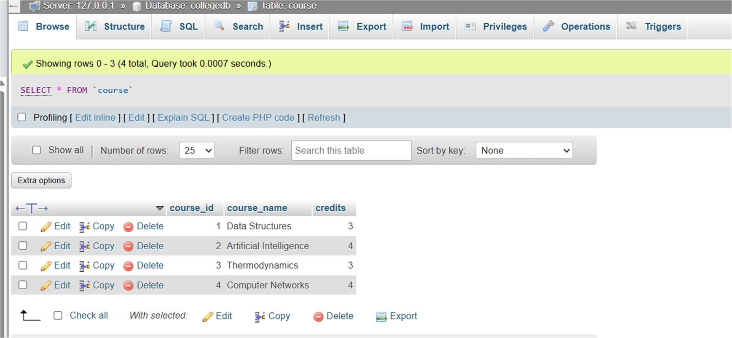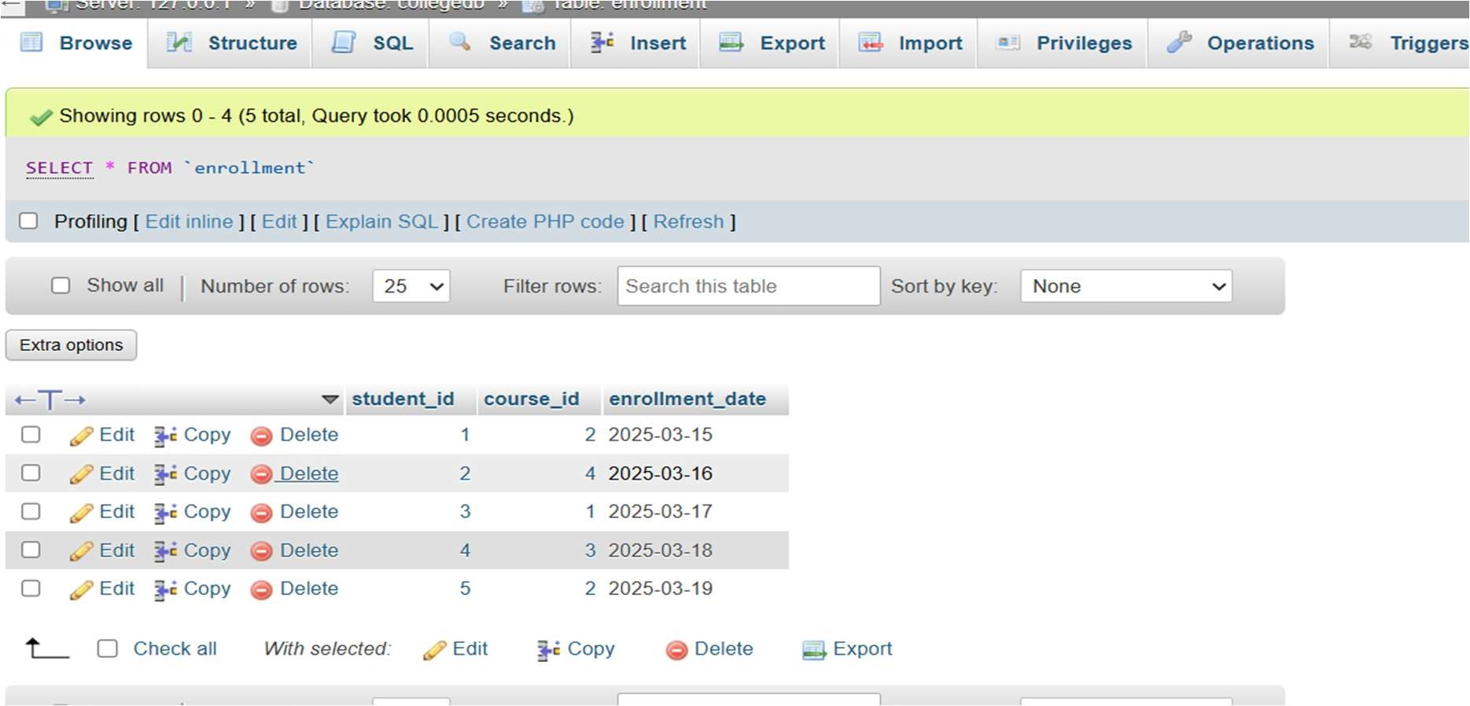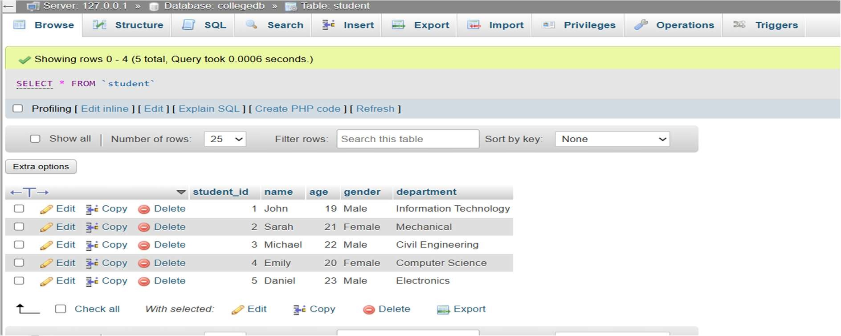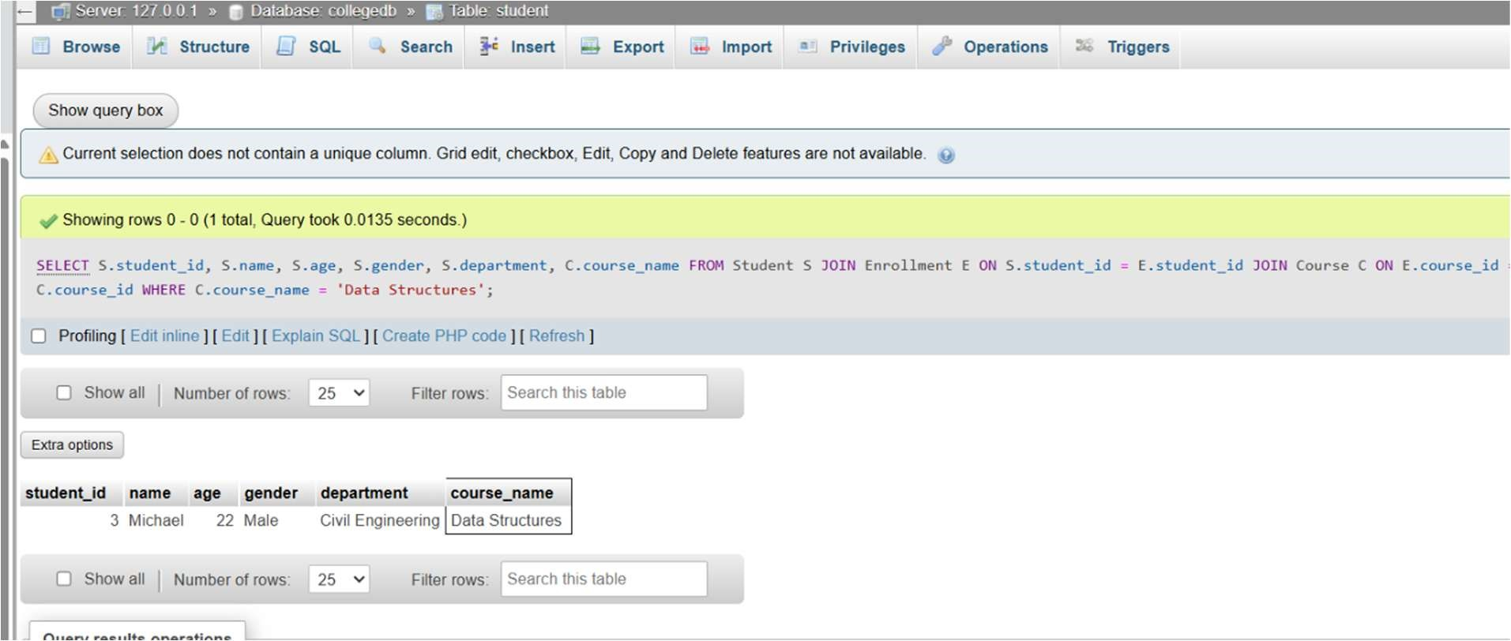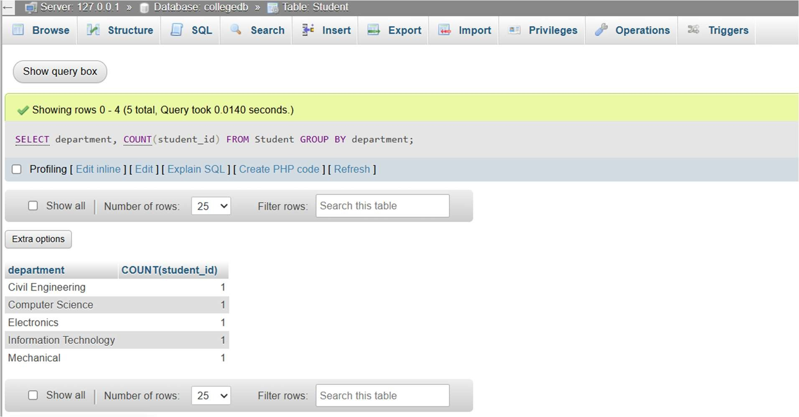

Q2

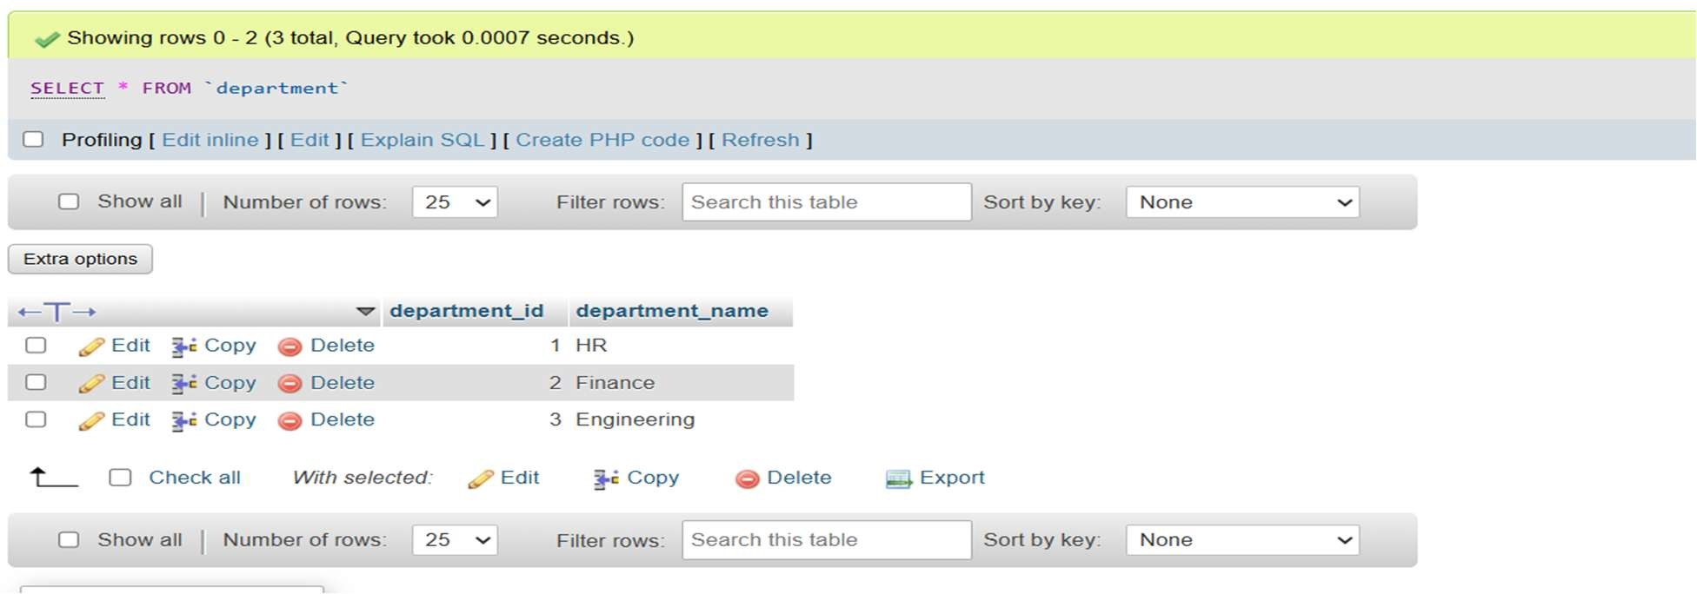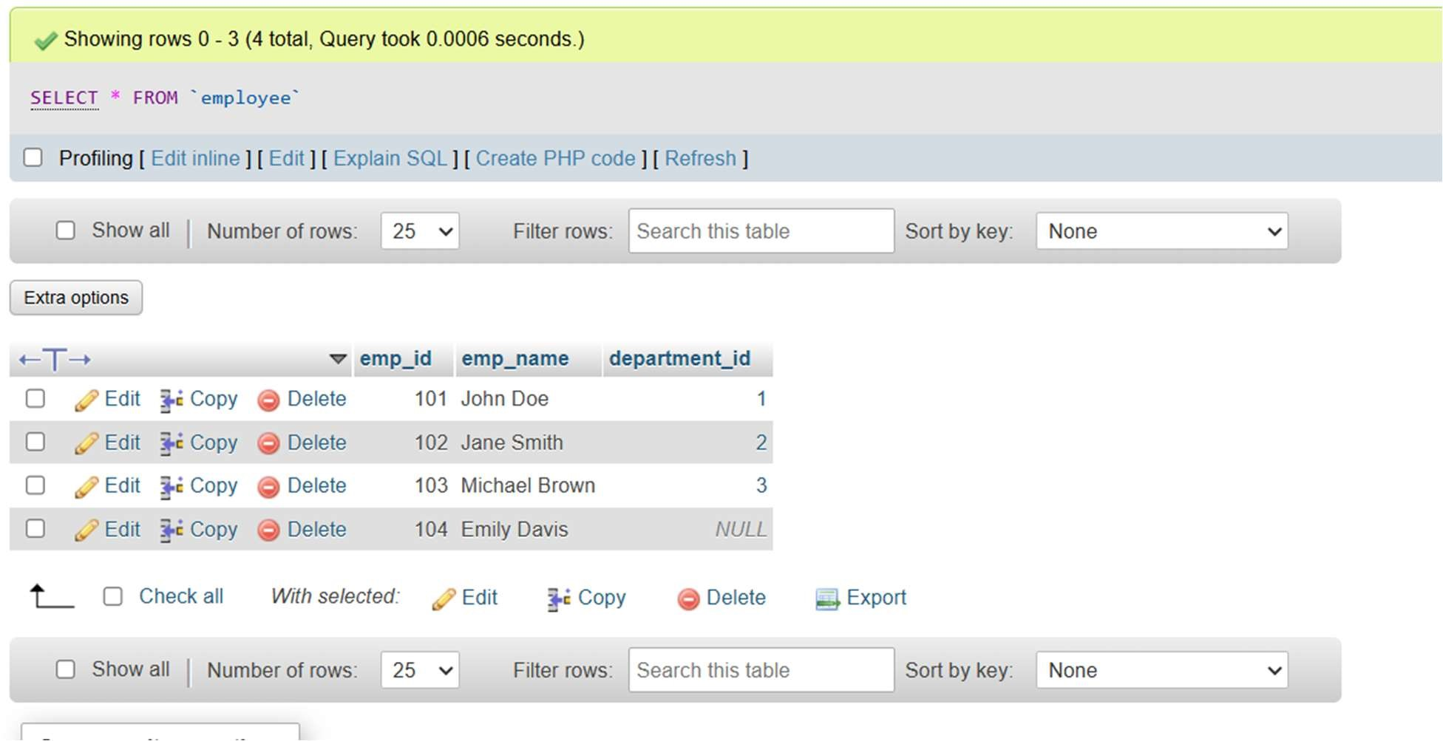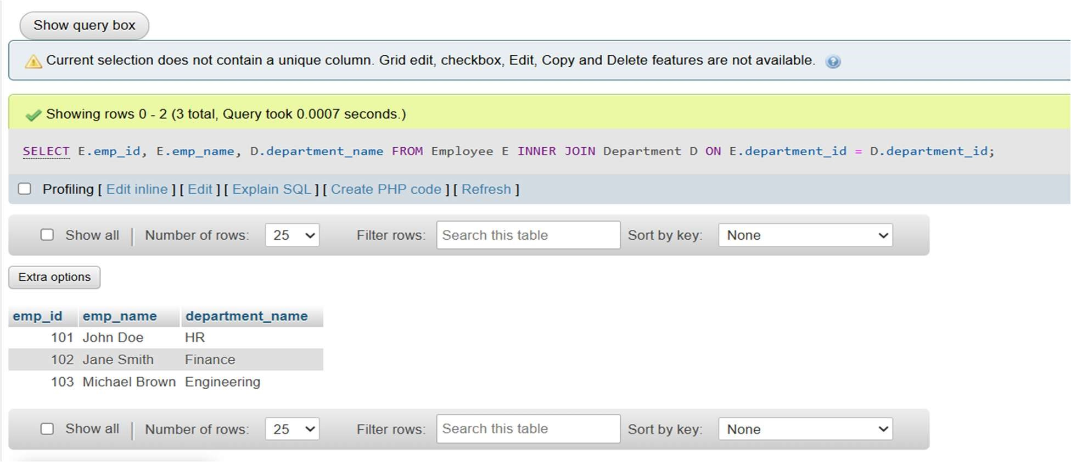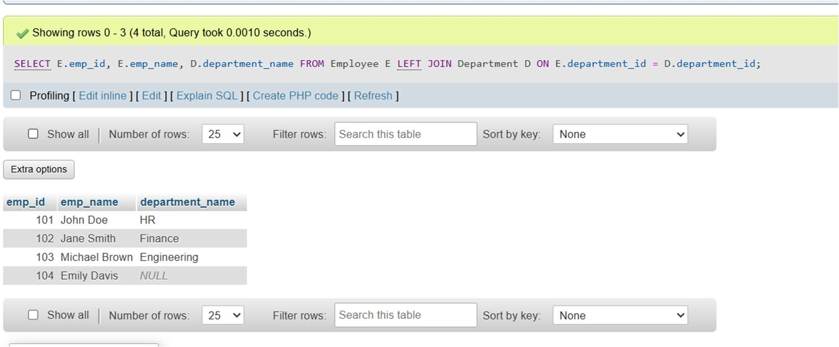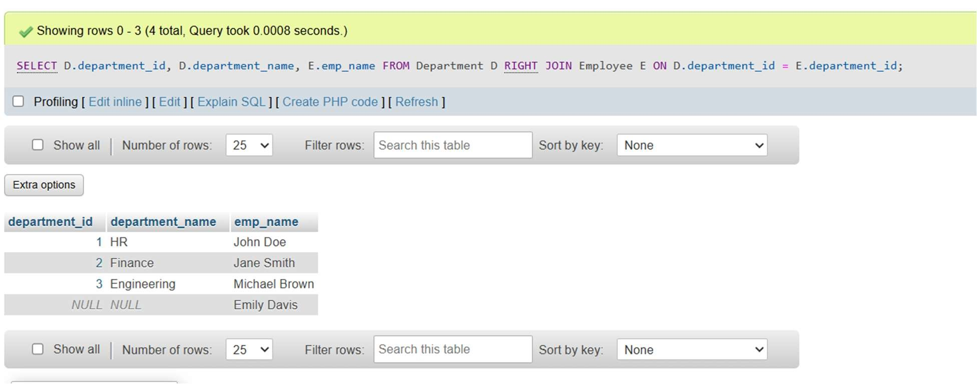

Q3

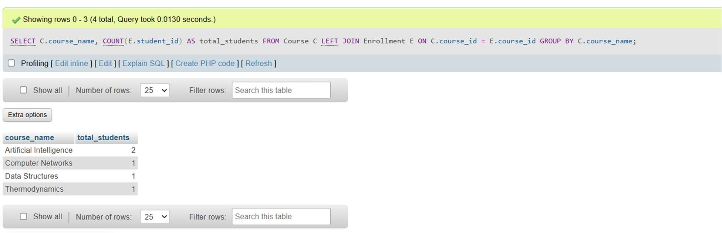

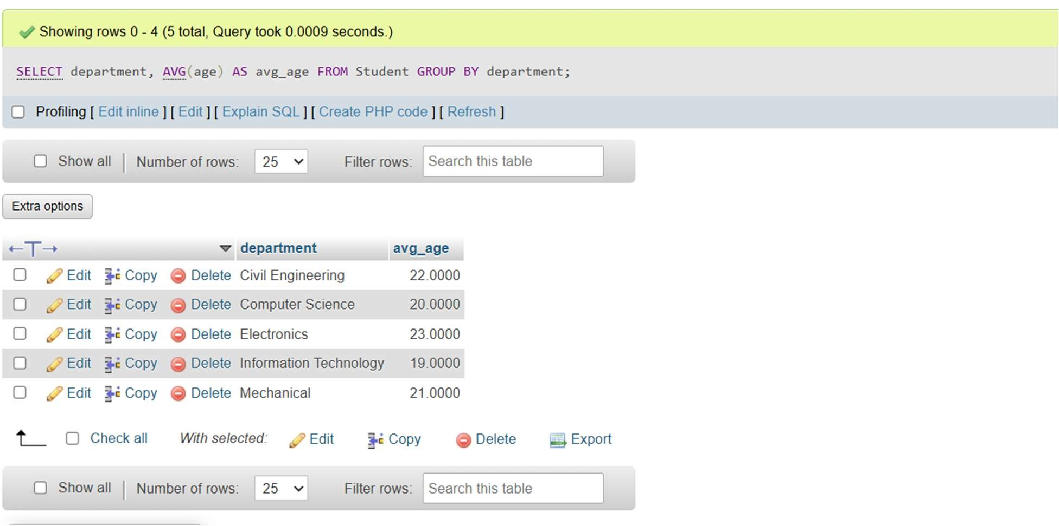

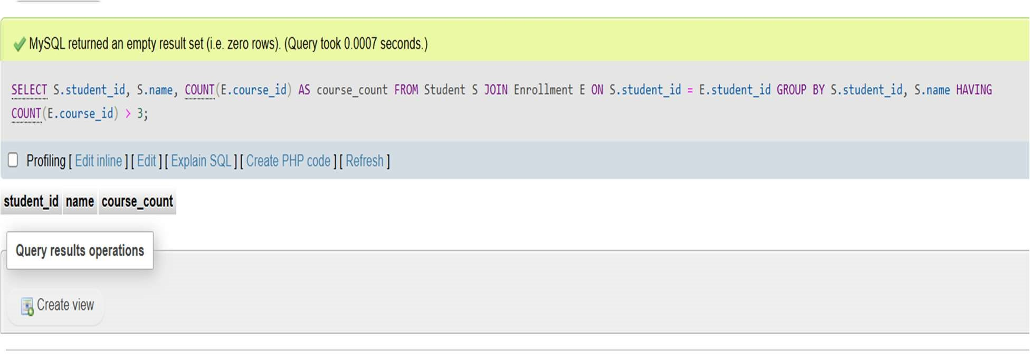

# EXPERIMENT 4

Q1. Develop a view named employee_contact_info that combines data from the employees and departments tables.

Q2. Create an updatable view and use it to modify data in the underlying table.

Q3. Design a table to store employee information, including fields like id, name, position, and salary

Create the salary_audit Table:

Design a table to log salary changes, including fields like audit_id, employee_id, old_salary, new_salary, and change_date.

Create a Trigger to Log Salary Changes:

Develop a BEFORE UPDATE trigger on the employees table that captures the old salary before any update and

inserts a record into the salary_audit table.

Q4. Design a table to store product details, including id, name, price, and a critical flag indicating if the product is essential.

Insert Sample Data: Populate the products table with sample records, marking some products as critical.

Develop a BEFORE DELETE trigger on the products table that checks if the critical flag is set. If so, the trigger prevents the deletion operation.

Q5.Design a table to store product information, including Product id, name, and stock quantity. Design a table to record sales transactions, including sale_id, product_id, quantity_sold, and sale_date.

Develop an AFTER INSERT trigger on the sales table that automatically updates the stock_quantity in the products table by subtracting the quantity_sold whenever a new sale is recorded.

SQL QUERY

Q1.

CREATE VIEW emp_dept_info AS

SELECT e.emp_id, e.name, e.salary, d.dept_id AS department_id, d.dept_name, d.location FROM emp e JOIN dept d ON e.dept_id = d.dept_id;

SELECT * FROM emp_dept_info;

Q2

CREATE VIEW emp_salary_view AS

SELECT emp_id, name, salaryFROM emp WITH CHECK OPTION;

SELECT * FROM emp_salary_view;

UPDATE emp_salary_view SET salary = 65000 WHERE emp_id = 201;

Q3.

CREATE TABLE FOR SALARY AUDIT

CREATE TABLE salary_audit ( audit_id INT PRIMARY KEY AUTO_INCREMENT, emp_id INT, old_salary DECIMAL(10,2), new_salary DECIMAL(10,2), change_date DATE,

FOREIGN KEY (emp_id) REFERENCES emp(emp_id)

);

APPLY TRIGGGERS

DELIMITER //

CREATE TRIGGER before_salary_update BEFORE UPDATE ON emp FOR EACH ROW

BEGIN

IF OLD.salary <> NEW.salary THEN

INSERT INTO salary_audit (emp_id, old_salary, new_salary)

VALUES (OLD.emp_id, OLD.salary, NEW.salary);

END IF;

END;

//

DELIMITER ;

CHECK ACTIVE TRIGGERS

SHOW TRIGGERS;

UPDATE VALUES TO CHECK THE TRIGGER FUNCTIONING

UPDATE emp SET salary = 60000 WHERE emp_id = 1;

SELECT * FROM salary_audit;

Q4.

CREATE TABLE AND INSERT VALUES

CREATE TABLE products (id INT PRIMARY KEY, name VARCHAR(100),price

DECIMAL(10,2),critical_flag BOOLEAN);

INSERT INTO products (id, name, price, critical_flag) VALUES

(1, 'Milk', 25.00, TRUE),

(2, 'Bread', 20.00, TRUE),

(3, 'Chocolate', 15.00, FALSE),

(4, 'Soap', 10.00, FALSE);

APPLY TRIGGER

DELIMITER $$

CREATE TRIGGER prevent_critical_delete

BEFORE DELETE ON products

FOR EACH ROW

BEGIN

IF OLD.critical_flag = TRUE THEN

SIGNAL SQLSTATE '45000'

SET MESSAGE_TEXT = 'Cannot delete critical product!';

END IF;

END$$

DELIMITER ;

CHECK THE TRIGGER

DELETE FROM products WHERE id = 1;

DELETE FROM products WHERE id = 3;

Q5.

CREATE TABLE AND INSERT VALUES

CREATE TABLE product_stock (product_id INT PRIMARY KEY, name VARCHAR(100), stock_quantity INT);

INSERT INTO product_stock (product_id, name, stock_quantity) VALUES

(1, 'Milk', 100),

(2, 'Bread', 50),

(3, 'Chocolate', 75);

CREATE SALES TABLE AND ADD TIGGER

CREATE TABLE sales (sale_id INT PRIMARY KEY AUTO_INCREMENT, product_id INT,quantity_sold INT,sale_date DATE);

DELIMITER $$

CREATE TRIGGER update_stock_after_sale

AFTER INSERT ON sales

FOR EACH ROW

BEGIN

UPDATE product_stock

SET stock_quantity = stock_quantity - NEW.quantity_sold

WHERE product_id = NEW.product_id;

END$$

DELIMITER ;

CHECK THE WORKING TRIGGER

INSERT INTO sales (product_id, quantity_sold, sale_date)

VALUES (1, 5, CURDATE());

SELECT * FROM product_stock WHERE product_id = 1;

OUTPUT

Q1.

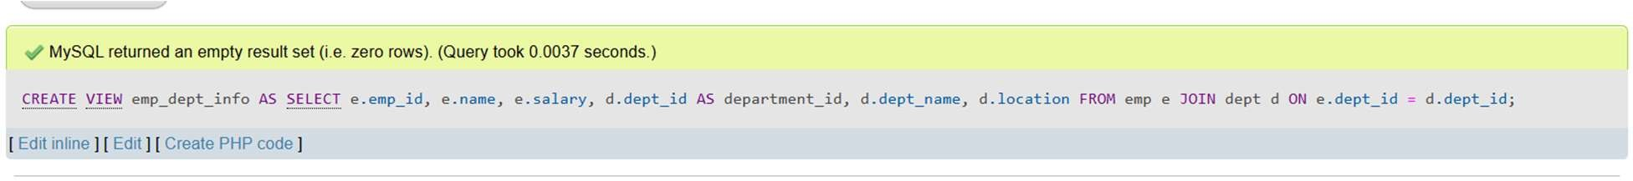

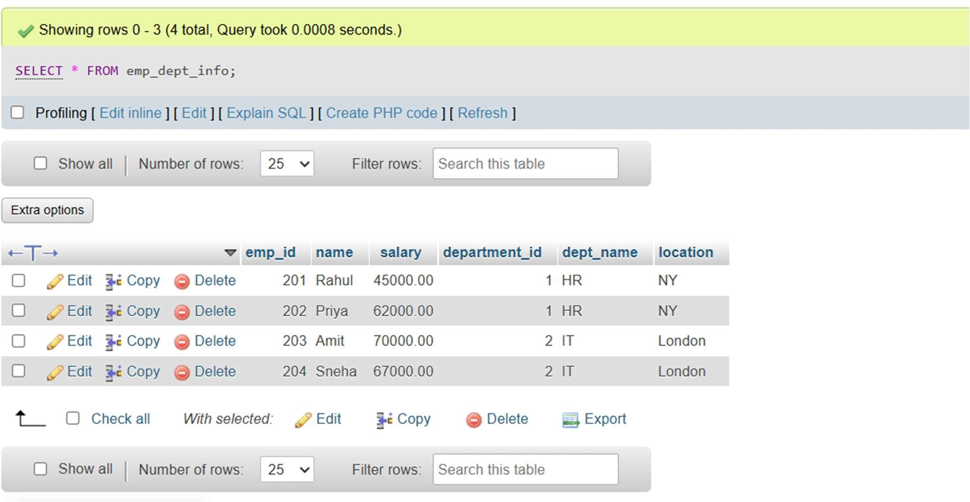

Q2.

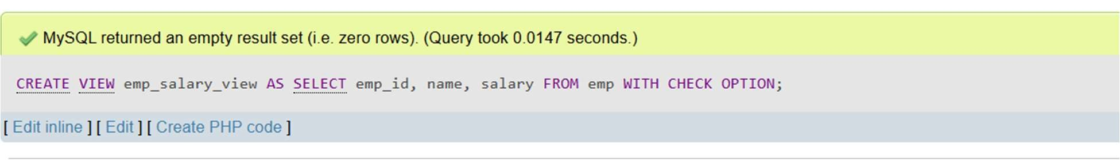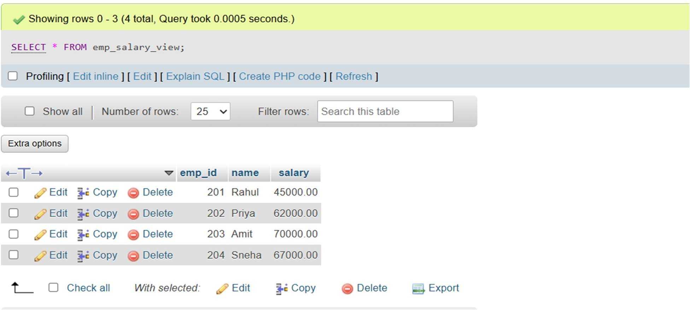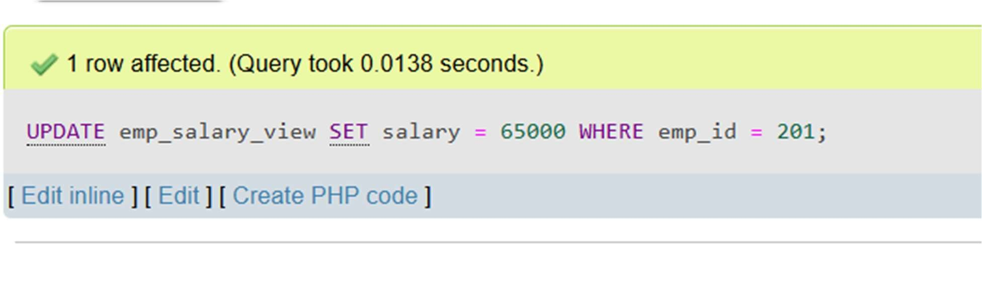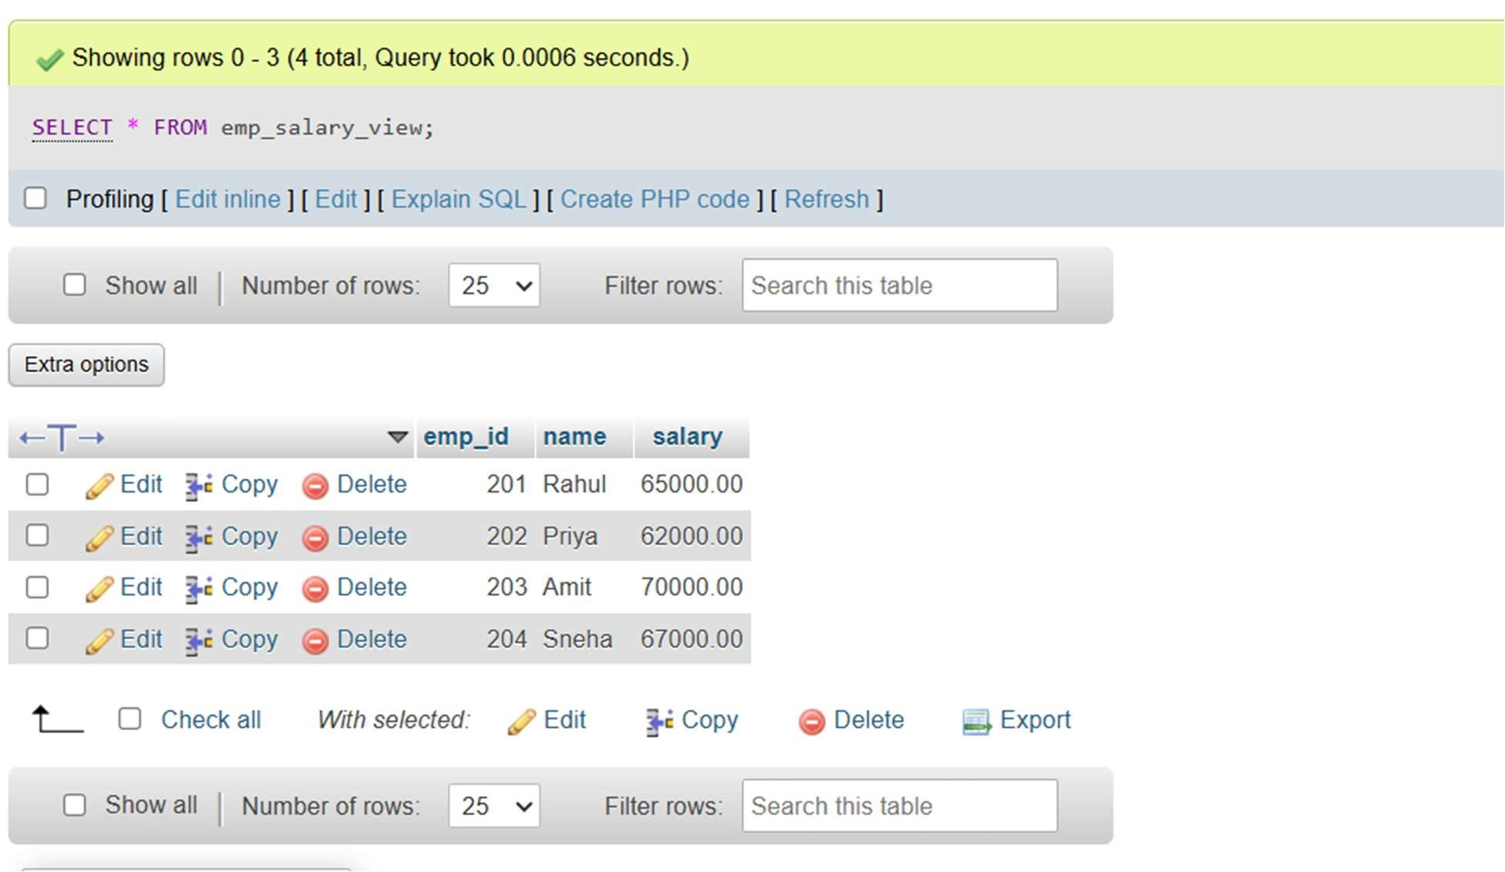

Q3.

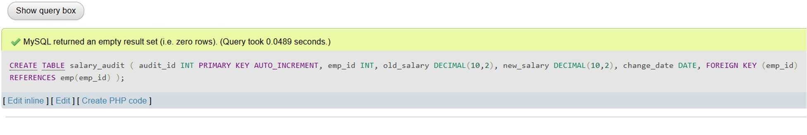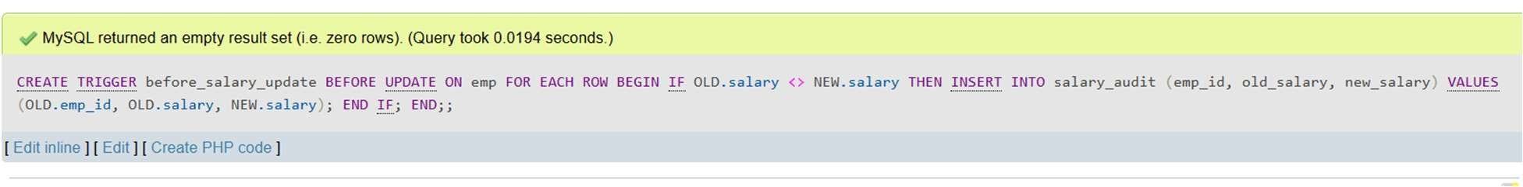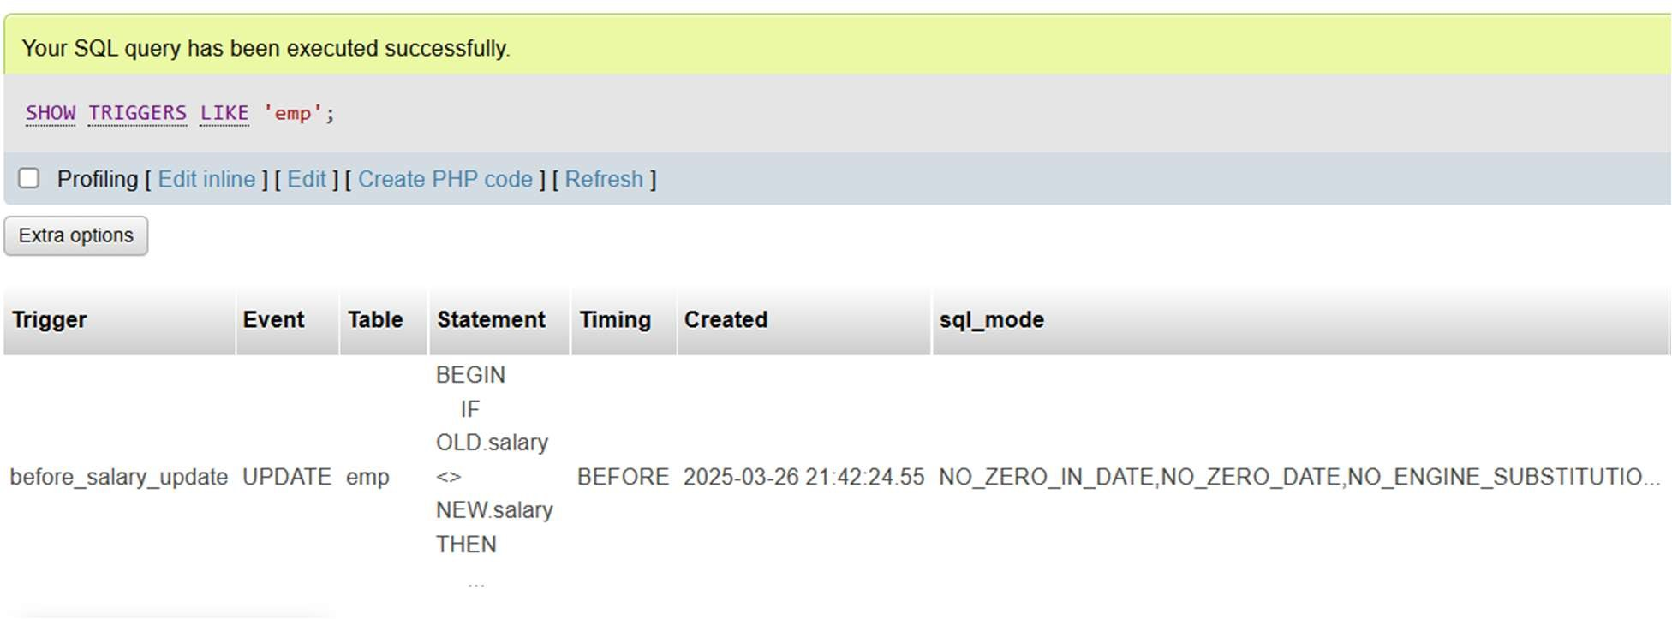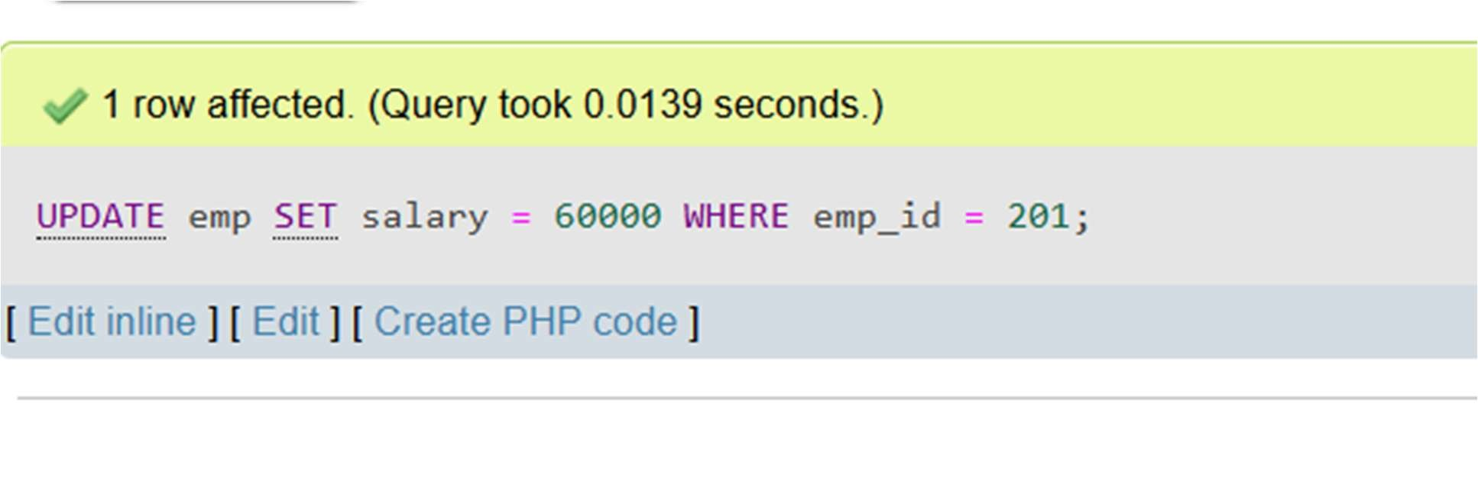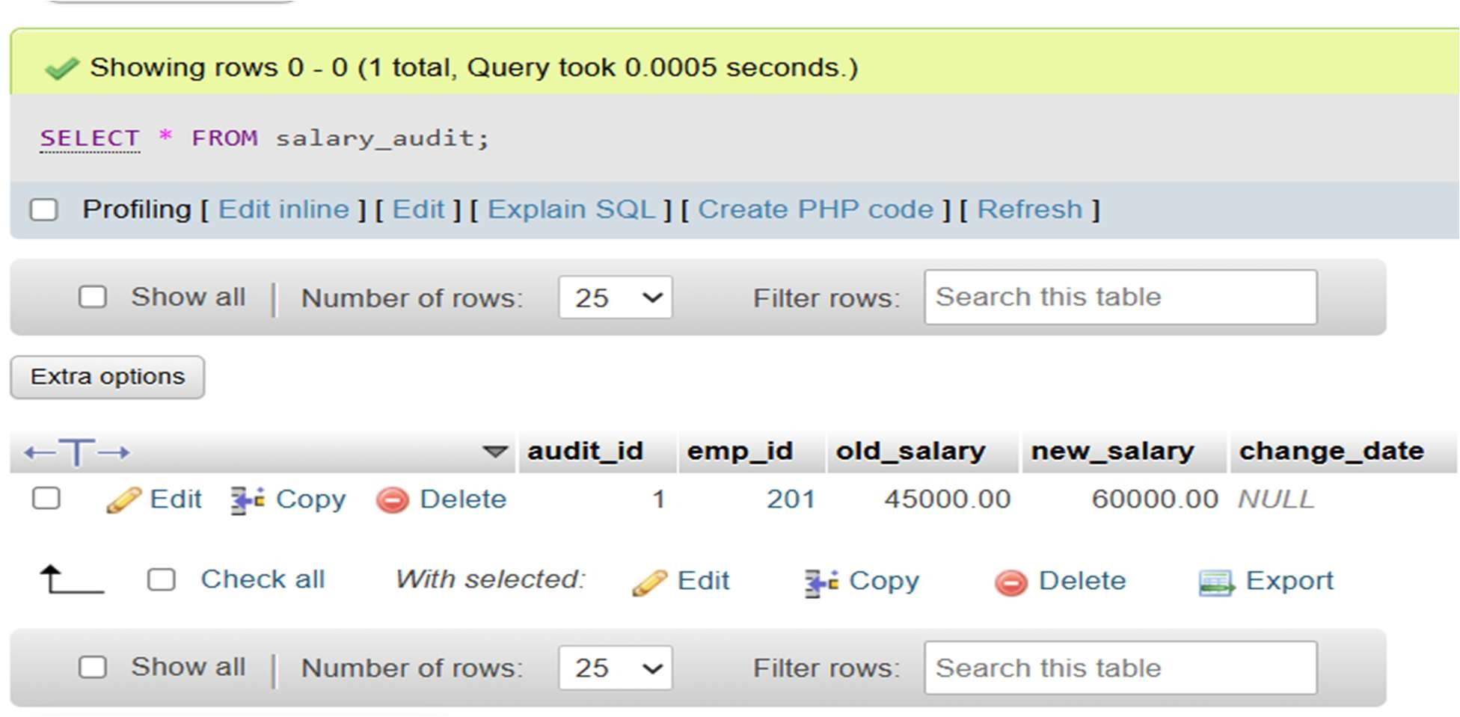

Q4.

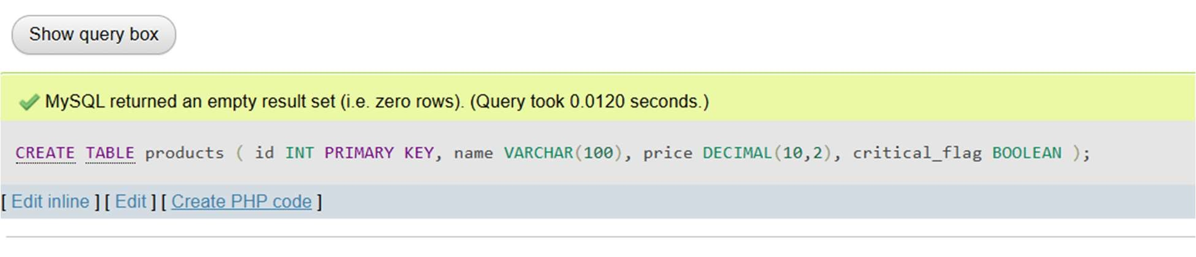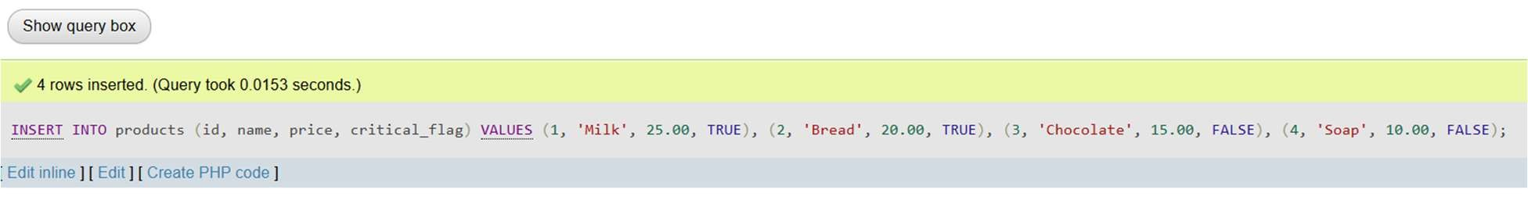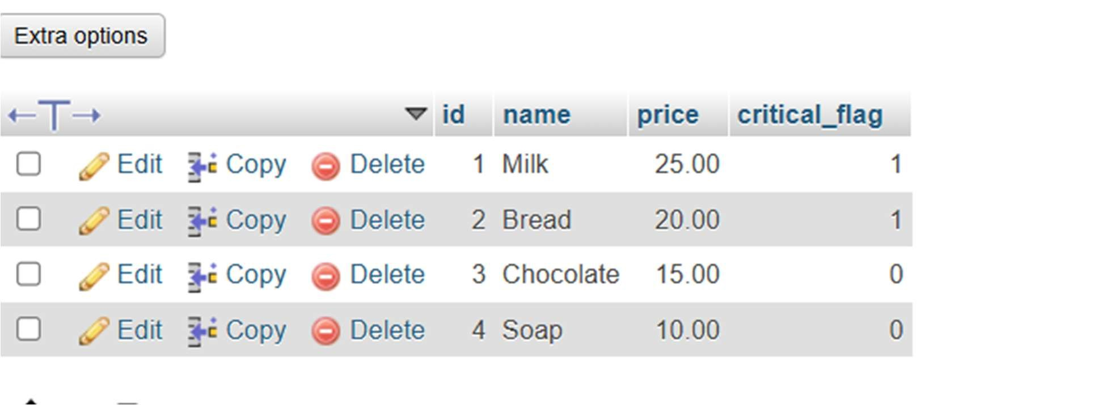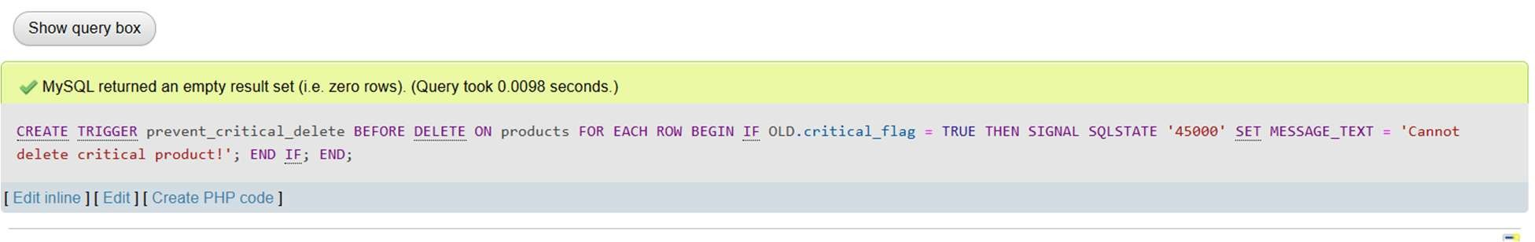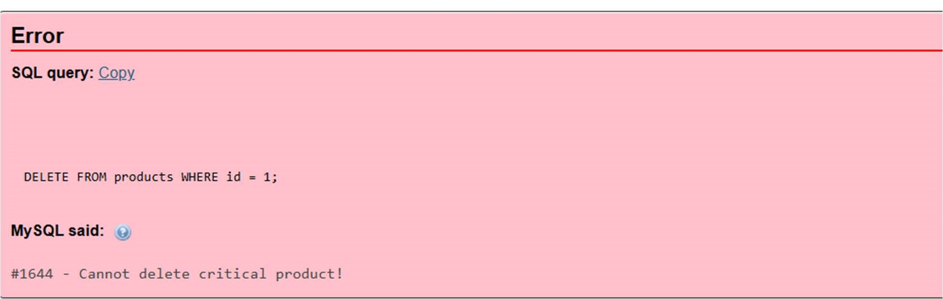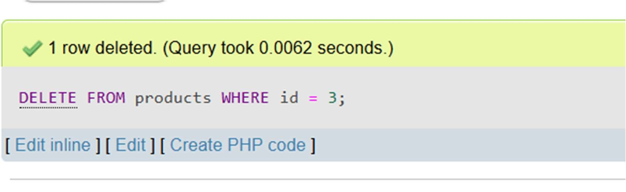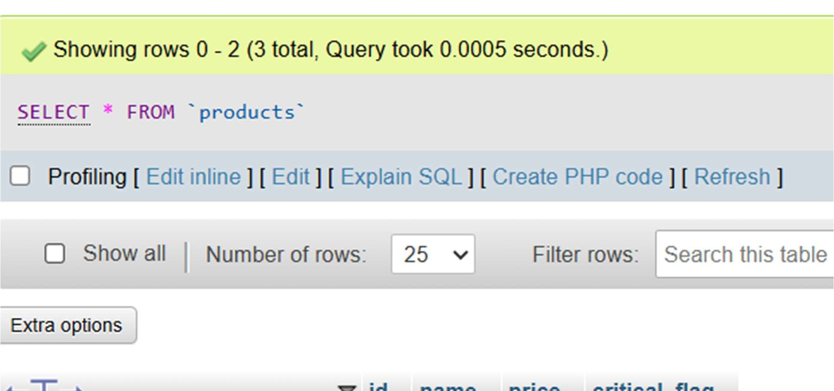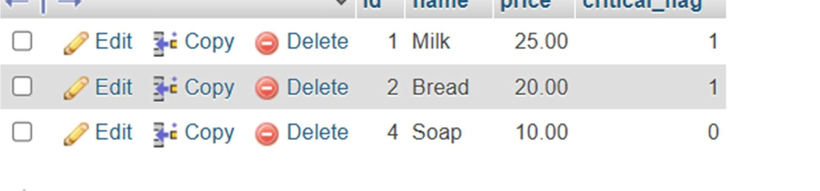

Q5.

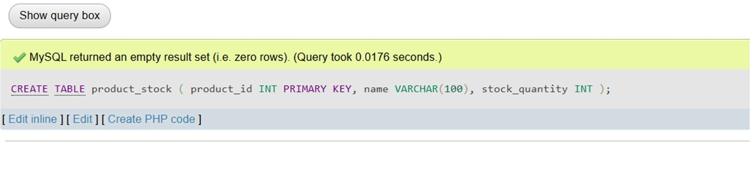

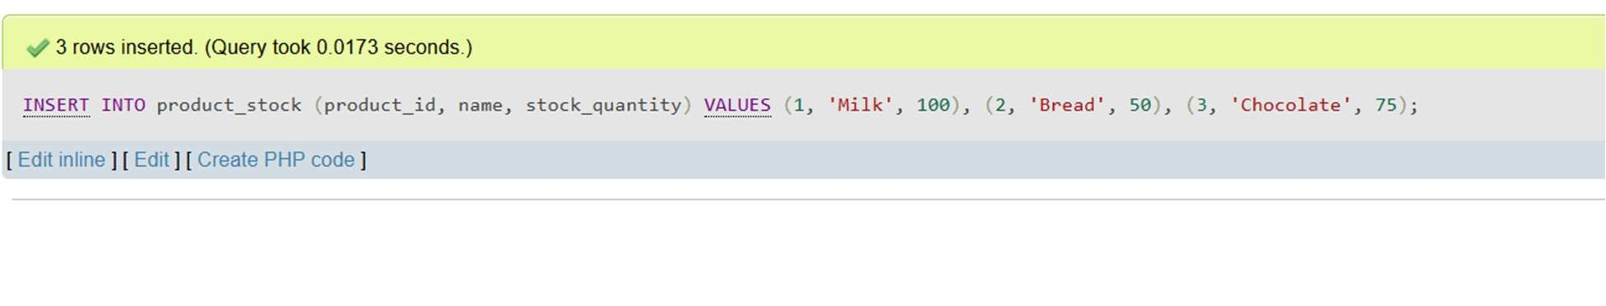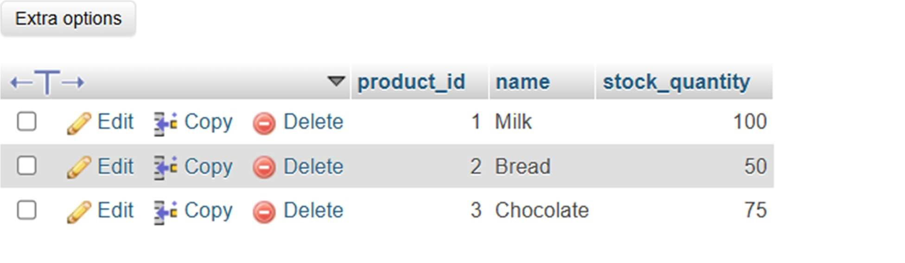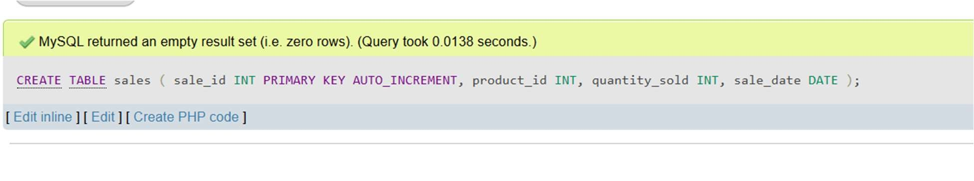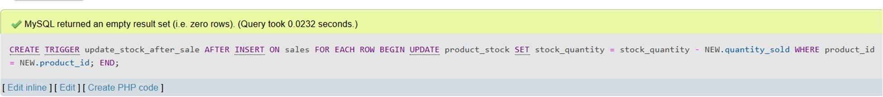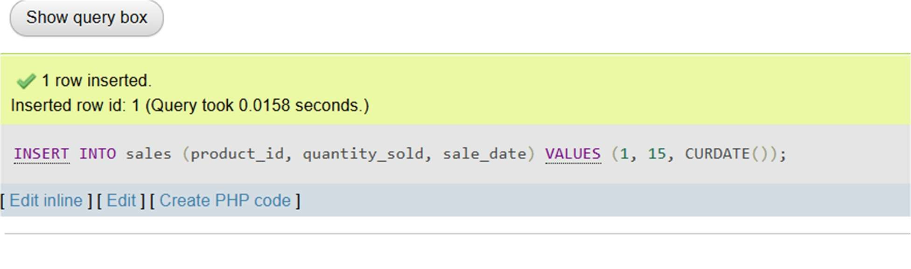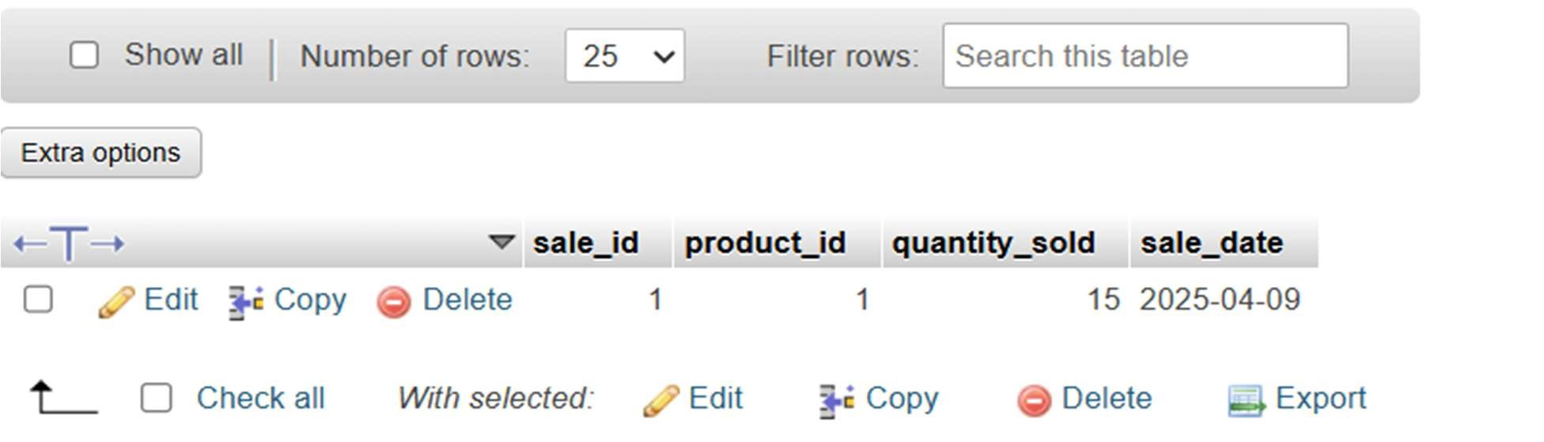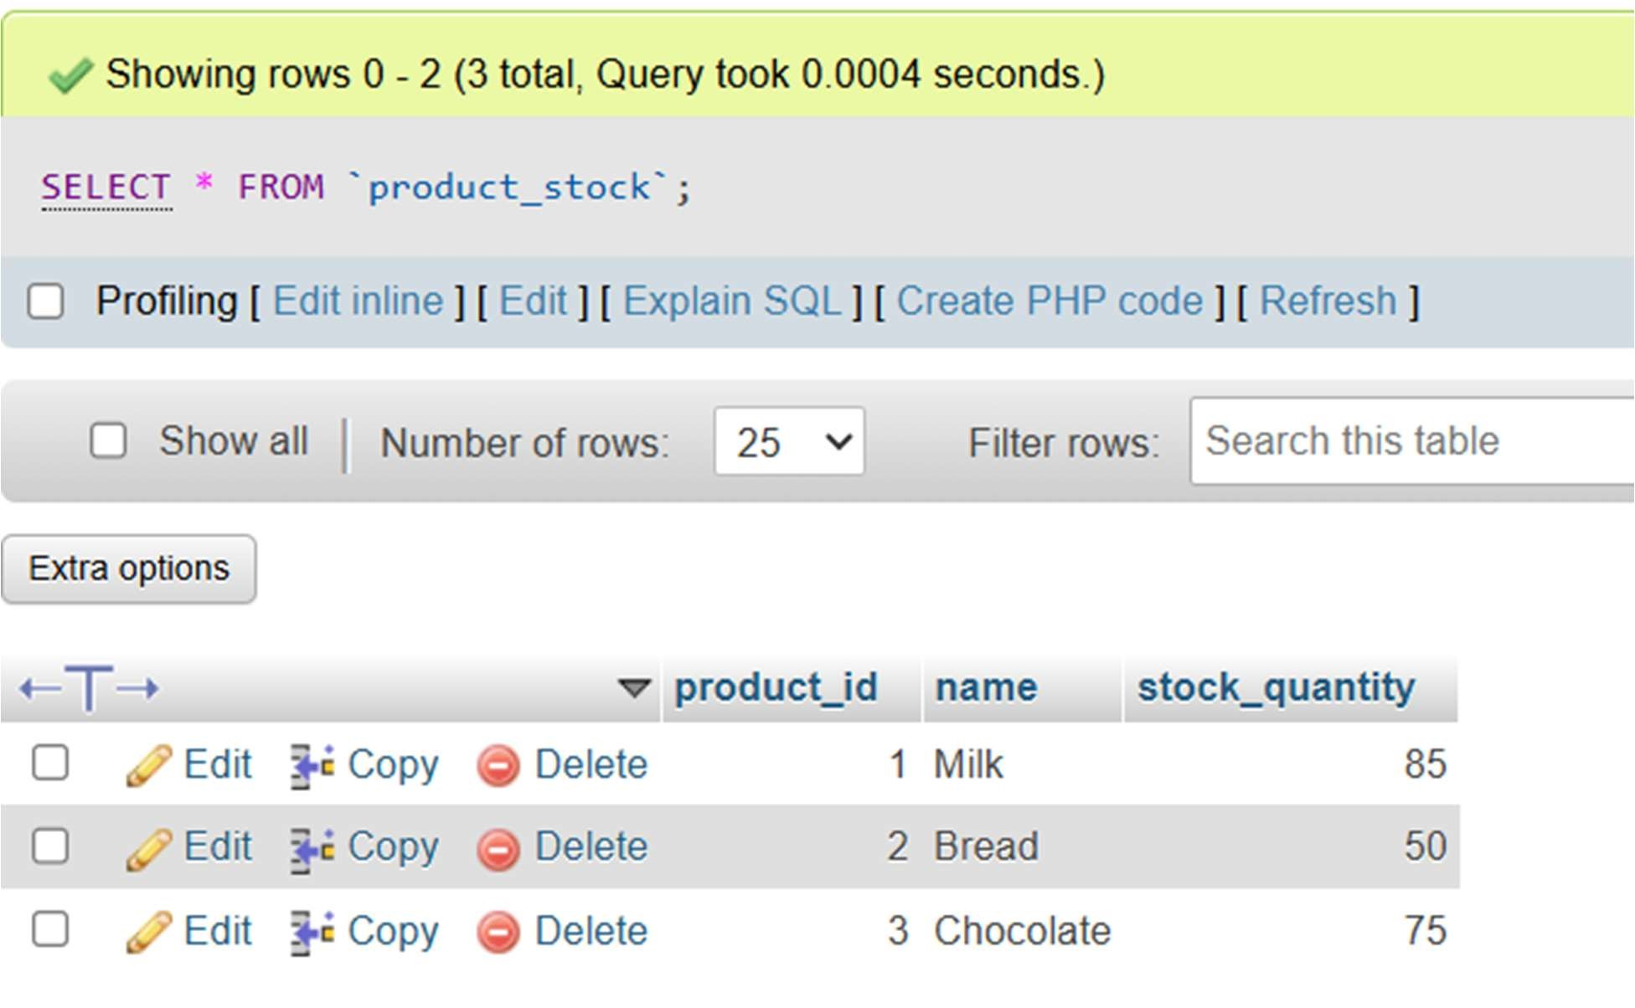

EXPERIMENT 5

Q1. Implement basic transaction control (BEGIN, COMMIT, ROLLBACK) Using some transaction processing statements.

Q2.Design a small database system for a university that stores information about students, courses, and enrollments using complex data types and object-oriented features in SQL.

USING SQL ANSWER THE FOLLOWING QUERIES

1. Retrieve all student names along with their city.
2. Get the list of courses and the number of topics in each.
3. Retrieve all faculty members' names and departments.
4. Show how inheritance works by querying both base and derived types.

SQL QUERY

Q1.

CREATE A TABLE

CREATE TABLE students ( student_id INT PRIMARY KEY,name VARCHAR(100),city VARCHAR(50)

);

COMMITED TRANSACTION

START TRANSACTION;

INSERT INTO students (student_id, name, city)

VALUES (1, 'John Doe', 'Delhi');

INSERT INTO students (student_id, name, city)

VALUES (2, 'Jane Doe', 'Mumbai');

COMMIT;

TRANSACTION THAT ROLLBACKED

START TRANSACTION;

INSERT INTO students (student_id, name, city)

VALUES (3, 'Amit Kumar', 'Chennai');

INSERT INTO students (student_id, name, city)

VALUES (1, 'Sunita Singh', 'Pune');

ROLLBACK;

Q2.

CREATE REQUIRED TABLES AND INSERT DATA

CREATE TABLE students (

student_id INT PRIMARY KEY,name VARCHAR(100), dob DATE, city VARCHAR(50)

);

CREATE TABLE courses (

course_id INT PRIMARY KEY,course_name VARCHAR(100), num_topics INT

);

CREATE TABLE faculty ( faculty_id INT PRIMARY KEY,name VARCHAR(100),dob DATE, city VARCHAR(50),department VARCHAR(100)

);

CREATE TABLE enrollments ( enrollment_id INT PRIMARY KEY, student_id INT,course_id INT,

FOREIGN KEY (student_id) REFERENCES students(student_id),

FOREIGN KEY (course_id) REFERENCES courses(course_id)

);

INSERT INTO students (student_id, name, dob, city) VALUES

(1, 'Ravi Kumar', '2002-03-15', 'Delhi'),

(2, 'Sneha Patel', '2001-06-21', 'Mumbai'),

(3, 'Amit Sharma', '2003-01-30', 'Chennai');

INSERT INTO courses (course_id, course_name, num_topics) VALUES

(101, 'Database Systems', 8),

(102, 'Operating Systems', 6),

(103, 'Computer Networks', 7);

INSERT INTO faculty (faculty_id, name, dob, city, department) VALUES

(201, 'Dr. Meena Rani', '1980-05-10', 'Delhi', 'Computer Science'),

(202, 'Dr. Arjun Desai', '1975-09-18', 'Mumbai', 'Information Technology');

INSERT INTO enrollments (enrollment_id, student_id, course_id) VALUES

(1, 1, 101),

(2, 2, 102),

(3, 3, 103);

1.

SELECT name AS Student_Name, city AS City FROM students;

2.

SELECT course_name AS Course_Name,num_topics AS Number_of_Topics FROM courses;

3.

SELECT name AS Faculty_Name,department AS Department FROM faculty;

4.

SELECT name, dob, city, 'Student' AS Role FROM students UNION ALL SELECT name, dob, city, 'Faculty' AS Role FROM faculty;

OUTPUT

Q1.

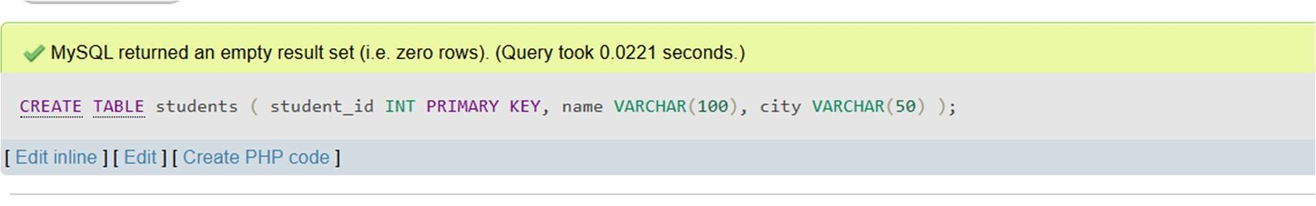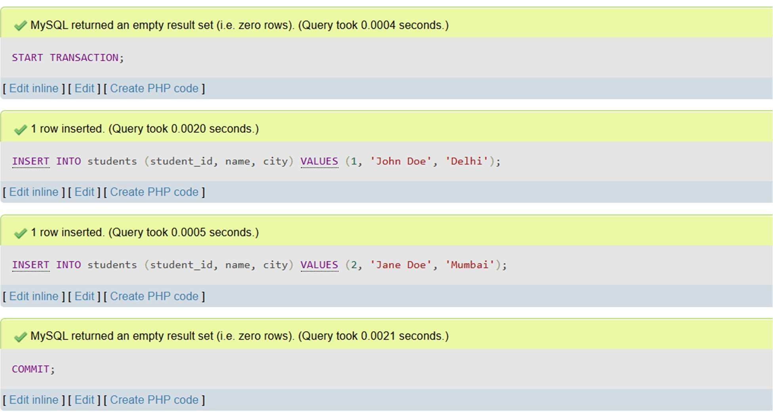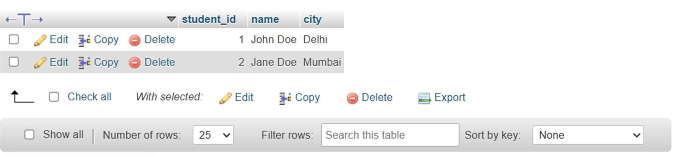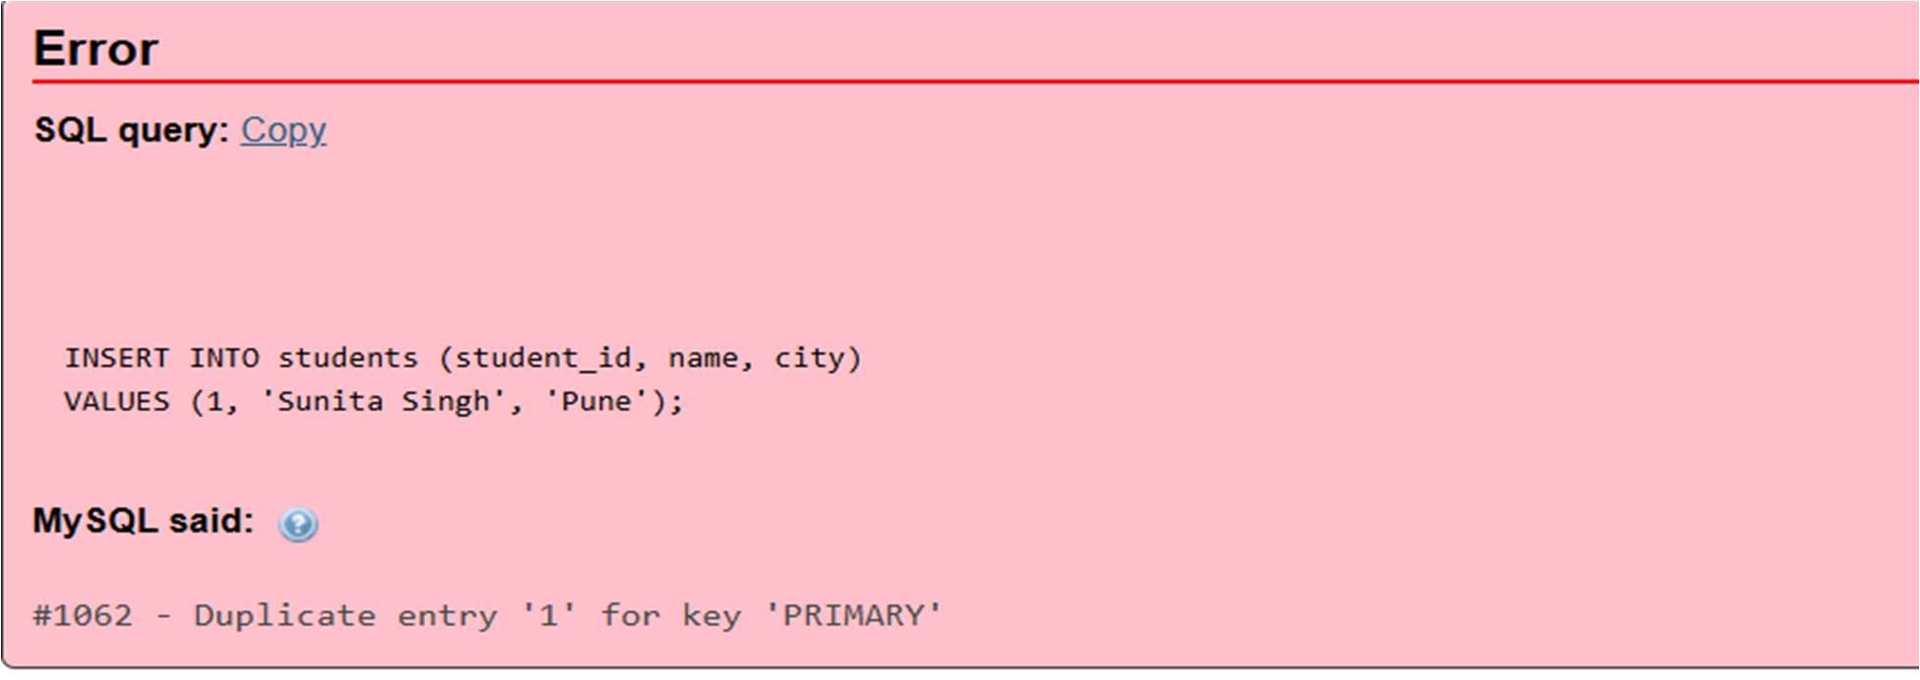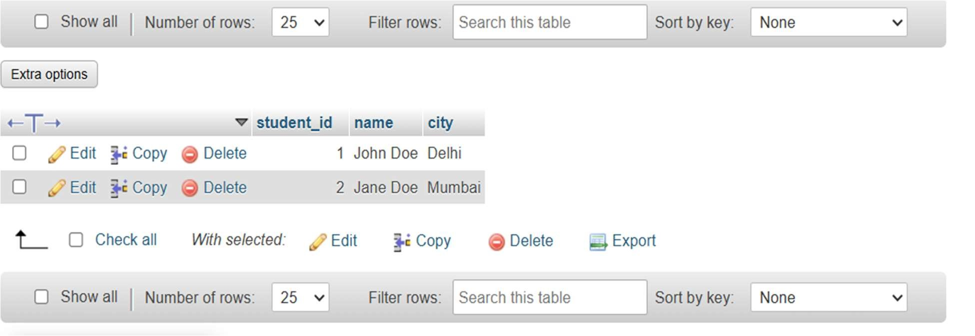

Q2.

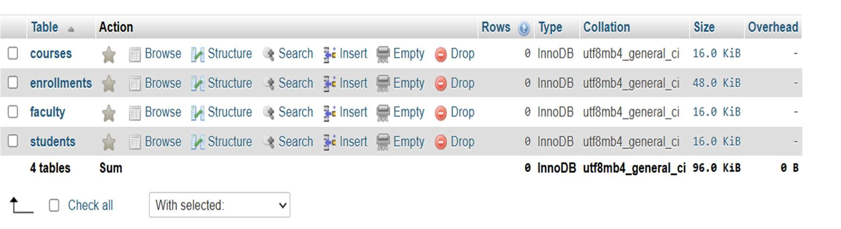

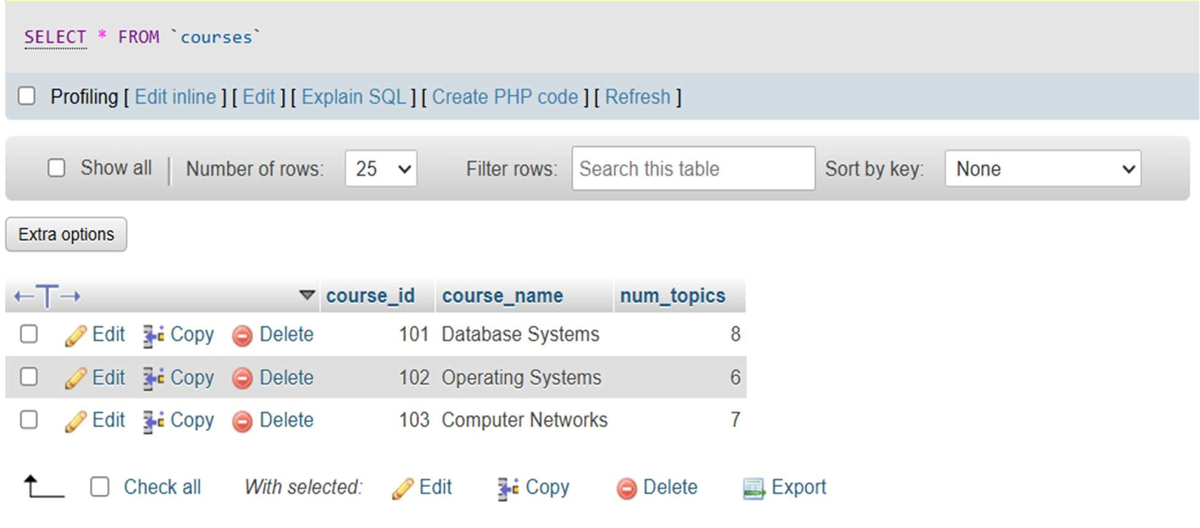

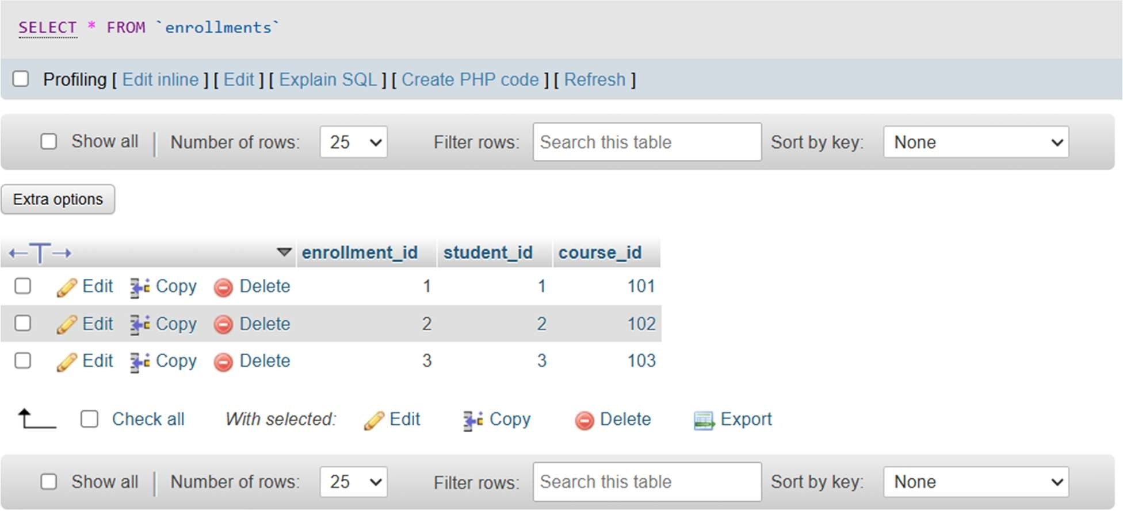

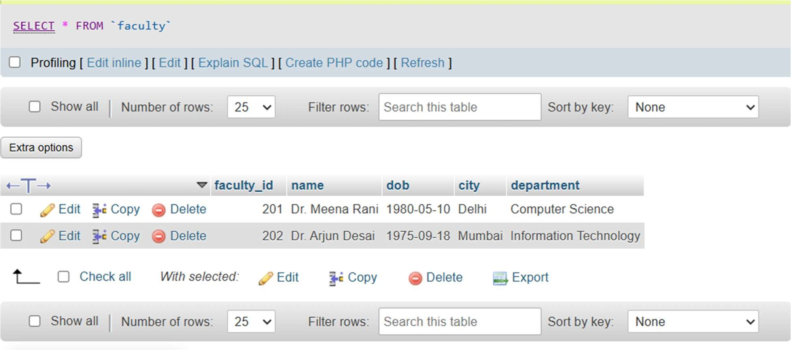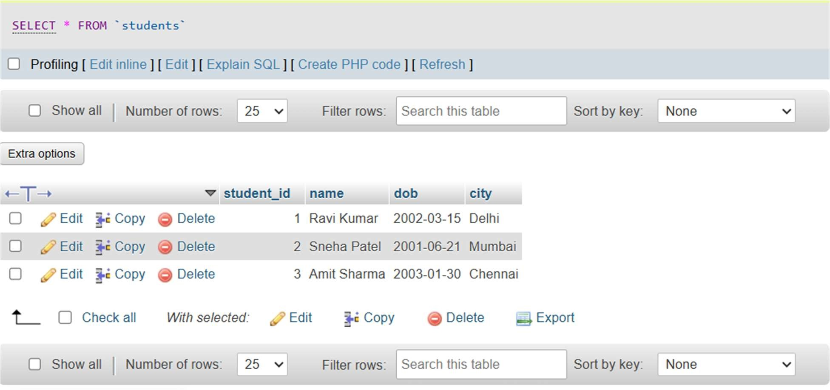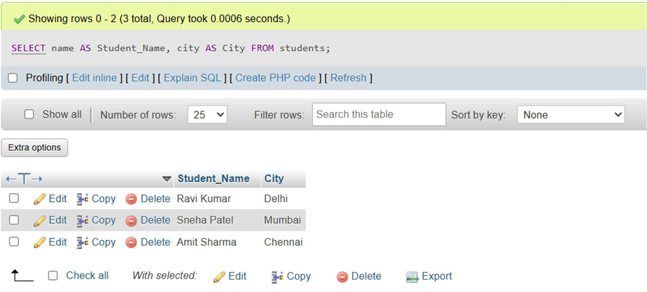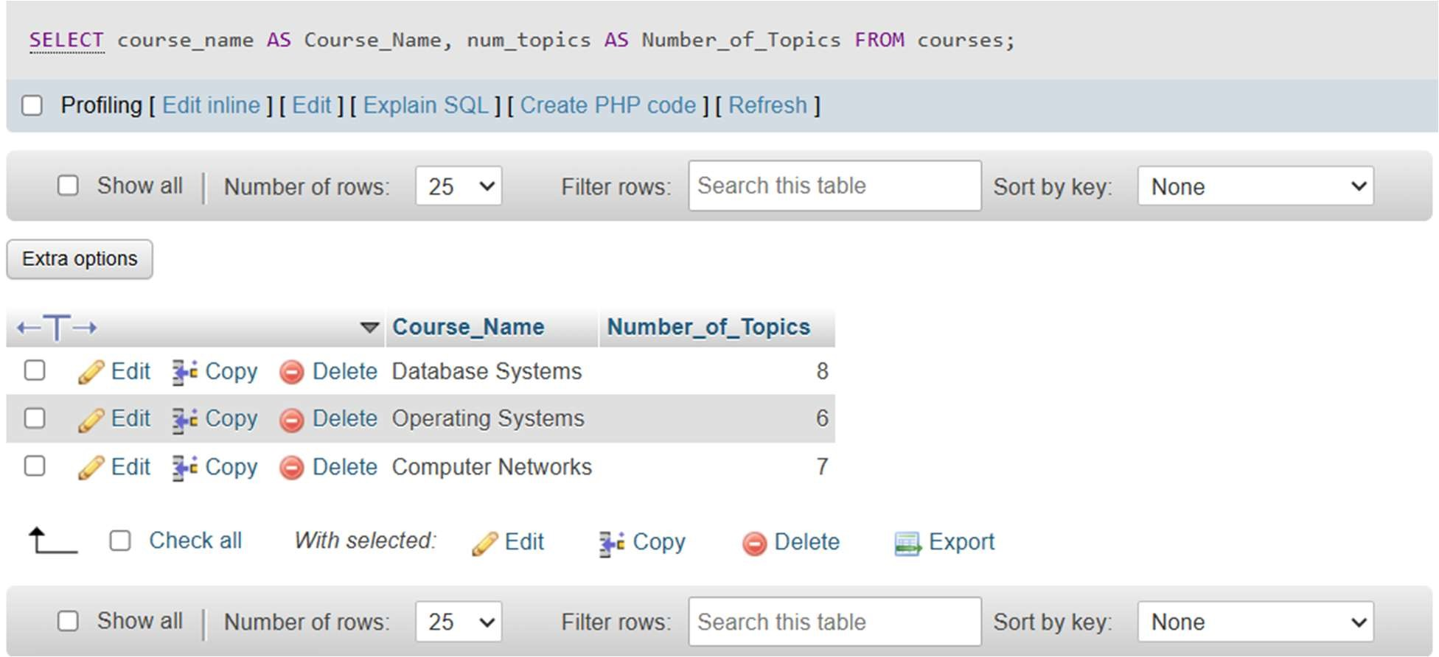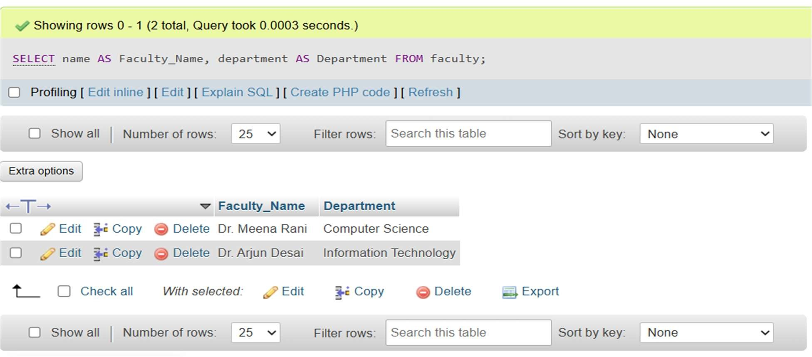

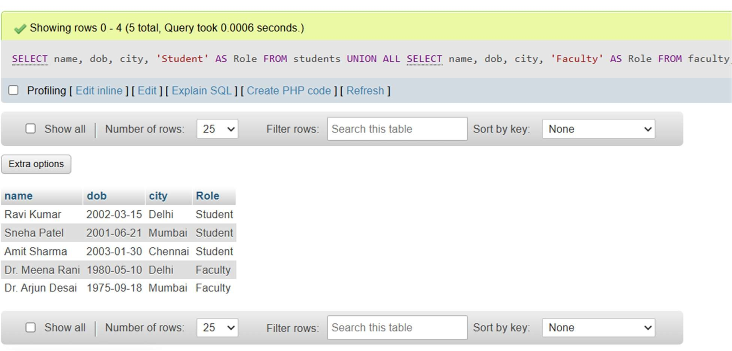

Experiment 6:

Design and build a simple database system and demonstrate competence with the fundamental tasks involved with modeling, designing, and implementing a DBMS.

AIM

To design and implement a simple database system (Hospital Management System) and perform basic database operations.

SQL QUERY

CREATE DATABASE

CREATE DATABASE hospital_db;

USE hospital_db;

CREATE REQUIRED TABLES

PATIENTS, DOCTORS, APPOINMENTS

ADD FOREIGN KEY CONSTRAINT TO APPOINMENTS

CREATE TABLE patients ( patient_id INT PRIMARY KEY,name VARCHAR(100), gender VARCHAR(10),dob DATE,city VARCHAR(50)

);

CREATE TABLE doctors (

doctor_id INT PRIMARY KEY,name VARCHAR(100), specialization VARCHAR(100),city VARCHAR(50)

);

CREATE TABLE appointments ( appointment_id INT PRIMARY KEY,

patient_id INT,doctor_id INT,appointment_date DATE, FOREIGN KEY (patient_id) REFERENCES patients(patient_id),

FOREIGN KEY (doctor_id) REFERENCES doctors(doctor_id)

);

INSERT THE DATA INTO TABLE

INSERT INTO patients (patient_id, name, gender, dob, city) VALUES

(1, 'Rohan Singh', 'Male', '1995-06-15', 'Mumbai'),

(2, 'Pooja Sharma', 'Female', '1998-08-22', 'Delhi'),

(3, 'Rahul Mehta', 'Male', '1992-12-05', 'Bangalore');

INSERT INTO doctors (doctor_id, name, specialization, city) VALUES

(101, 'Dr. Anita Desai', 'Cardiology', 'Mumbai'),

(102, 'Dr. Suresh Menon', 'Orthopedics', 'Bangalore');

INSERT INTO appointments (appointment_id, patient_id, doctor_id, appointment_date) VALUES

(1, 1, 101, '2024-04-20'),

(2, 2, 102, '2024-04-21'),

(3, 3, 102, '2024-04-22');

BASIC OPERATIONS

DISPLAY THE TABLE

SELECT * FROM patients;

SELECT * FROM doctors;

SELECT * FROM appointments;

UPDATE QUERY

UPDATE doctors SET specialization = 'Neurology' WHERE doctor_id = 102;

DELETION QUERY

DELETE FROM appointments WHERE patient_id = 3;

\

ALTER QUERY

ALTER TABLE doctors ADD email VARCHAR(100);

ALTER TABLE doctors DROP COLUMN email;

DISPLAY PATIENT ASSIGNED TO THE DOCTOR SELECT patients.name AS Patient_Name, doctors.name AS Doctor_Name, appointments.appointment_dateFROM appointments JOIN patients ON appointments.patient_id = patients.patient_id

JOIN doctors ON appointments.doctor_id = doctors.doctor_id;

OUTPUT

